# Sites that were included

NSABHC0028 Test Set: (Timestamp('1998-06-23 00:00:00'), Timestamp('2003-07-07 00:00:00')), Period: 86  
  
NSABHC0029 Test Set: (Timestamp('2011-10-01 00:00:00'), Timestamp('2015-02-22 00:00:00')), Period: 86  
  
NSACHC0002 Test Set: (Timestamp('2006-02-13 00:00:00'), Timestamp('2009-03-01 00:00:00')), Period: 89  
  
NSACHC0003 Test Set: (Timestamp('2012-07-07 00:00:00'), Timestamp('2015-04-27 00:00:00')), Period: 89  
  
NSACOP0001 Test Set: (Timestamp('2015-03-05 00:00:00'), Timestamp('2017-09-26 00:00:00')), Period: 81  
  
NSACOP0002 Test Set: (Timestamp('2017-07-24 00:00:00'), Timestamp('2019-12-05 00:00:00')), Period: 79  
  
NSAMDD0002 Test Set: (Timestamp('1987-09-21 00:00:00'), Timestamp('1993-04-14 00:00:00')), Period: 78  
  
NSAMDD0005 Test Set: (Timestamp('2005-09-08 00:00:00'), Timestamp('2008-07-05 00:00:00')), Period: 155  
  
NSAMDD0009 Test Set: (Timestamp('2009-02-05 00:00:00'), Timestamp('2012-09-25 00:00:00')), Period: 76  
  
NSAMDD0011 Test Set: (Timestamp('1993-12-17 00:00:00'), Timestamp('1999-02-18 00:00:00')), Period: 77  
  
NSAMDD0013 Test Set: (Timestamp('2003-08-24 00:00:00'), Timestamp('2006-03-01 00:00:00')), Period: 78  
  
NSAMDD0015 Test Set: (Timestamp('2008-11-09 00:00:00'), Timestamp('2011-10-25 00:00:00')), Period: 76  
  
NSAMDD0017 Test Set: (Timestamp('2008-09-16 00:00:00'), Timestamp('2011-10-11 00:00:00')), Period: 80  
  
NSAMDD0018 Test Set: (Timestamp('2011-11-21 00:00:00'), Timestamp('2015-01-16 00:00:00')), Period: 79  
  
NSAMDD0020 Test Set: (Timestamp('2011-08-24 00:00:00'), Timestamp('2015-01-16 00:00:00')), Period: 80  
  
NSAMDD0025 Test Set: (Timestamp('1993-03-22 00:00:00'), Timestamp('1998-10-30 00:00:00')), Period: 86  
  
NSAMDD0027 Test Set: (Timestamp('2017-12-22 00:00:00'), Timestamp('2020-06-05 00:00:00')), Period: 87  
  
NSAMDD0030 Test Set: (Timestamp('2017-10-03 00:00:00'), Timestamp('2020-03-24 00:00:00')), Period: 88  
  
NSAMDD0032 Test Set: (Timestamp('2008-09-16 00:00:00'), Timestamp('2012-03-28 00:00:00')), Period: 81  
  
NSAMUL0002 Test Set: (Timestamp('2015-03-28 00:00:00'), Timestamp('2017-12-14 00:00:00')), Period: 91  
  
NSAMUL0003 Test Set: (Timestamp('2017-09-25 00:00:00'), Timestamp('2019-12-19 00:00:00')), Period: 90  
  
NSAMUL0004 Test Set: (Timestamp('2017-10-27 00:00:00'), Timestamp('2020-01-29 00:00:00')), Period: 90  
  
NTAFIN0003 Test Set: (Timestamp('2020-11-28 00:00:00'), Timestamp('2022-12-04 00:00:00')), Period: 82  
  
NTAFIN0013 Test Set: (Timestamp('1992-05-31 00:00:00'), Timestamp('1998-10-14 00:00:00')), Period: 150  
  
NTAFIN0015 Test Set: (Timestamp('1987-09-07 00:00:00'), Timestamp('1992-05-31 00:00:00')), Period: 149  
  
NTAFIN0024 Test Set: (Timestamp('2015-12-09 00:00:00'), Timestamp('2018-04-29 00:00:00')), Period: 85  
  
NTAMAC0002 Test Set: (Timestamp('2003-09-03 00:00:00'), Timestamp('2006-08-26 00:00:00')), Period: 128  
  
QDACHC0001 Test Set: (Timestamp('1998-11-14 00:00:00'), Timestamp('2003-10-27 00:00:00')), Period: 95  
  
QDACHC0002 Test Set: (Timestamp('2020-03-23 00:00:00'), Timestamp('2022-12-10 00:00:00')), Period: 94  
  
QDACHC0003 Test Set: (Timestamp('2011-11-10 00:00:00'), Timestamp('2015-03-26 00:00:00')), Period: 94  
  
QDAMGD0015 Test Set: (Timestamp('2013-12-01 00:00:00'), Timestamp('2016-03-27 00:00:00')), Period: 121  
  
QDAMGD0016 Test Set: (Timestamp('1998-11-14 00:00:00'), Timestamp('2003-10-19 00:00:00')), Period: 96  
  
QDAMGD0020 Test Set: (Timestamp('1993-08-18 00:00:00'), Timestamp('1999-07-03 00:00:00')), Period: 93  
  
QDAMUL0001 Test Set: (Timestamp('2009-02-14 00:00:00'), Timestamp('2012-07-16 00:00:00')), Period: 93  
  
QDAMUL0002 Test Set: (Timestamp('2020-05-02 00:00:00'), Timestamp('2022-12-27 00:00:00')), Period: 93  
  
QDAMUL0003 Test Set: (Timestamp('1993-06-01 00:00:00'), Timestamp('1998-08-02 00:00:00')), Period: 93  
  
QDASSD0005 Test Set: (Timestamp('2012-12-03 00:00:00'), Timestamp('2015-07-21 00:00:00')), Period: 95  
  
QDASSD0011 Test Set: (Timestamp('2007-08-08 00:00:00'), Timestamp('2010-06-21 00:00:00')), Period: 156  
  
SAABHC0004 Test Set: (Timestamp('1992-11-28 00:00:00'), Timestamp('1998-05-13 00:00:00')), Period: 153  
  
SAAFLB0008 Test Set: (Timestamp('2004-03-01 00:00:00'), Timestamp('2006-07-29 00:00:00')), Period: 79  
  
SAAGAW0001 Test Set: (Timestamp('1987-09-11 00:00:00'), Timestamp('1992-08-07 00:00:00')), Period: 132  
  
SAAGAW0004 Test Set: (Timestamp('1999-07-16 00:00:00'), Timestamp('2004-03-07 00:00:00')), Period: 85  
  
SAARIV0001 Test Set: (Timestamp('1999-07-28 00:00:00'), Timestamp('2003-12-06 00:00:00')), Period: 70  
  
SAARIV0002 Test Set: (Timestamp('2004-01-23 00:00:00'), Timestamp('2006-06-05 00:00:00')), Period: 70  
  
SAARIV0003 Test Set: (Timestamp('1999-08-05 00:00:00'), Timestamp('2003-12-14 00:00:00')), Period: 70  
  
SASMDD0001 Test Set: (Timestamp('1987-12-01 00:00:00'), Timestamp('1994-03-07 00:00:00')), Period: 75  
  
SASMDD0002 Test Set: (Timestamp('2006-04-18 00:00:00'), Timestamp('2009-01-12 00:00:00')), Period: 72  
  
SASMDD0006 Test Set: (Timestamp('2006-01-12 00:00:00'), Timestamp('2008-11-09 00:00:00')), Period: 70  
  
SASMDD0008 Test Set: (Timestamp('2015-04-11 00:00:00'), Timestamp('2017-08-06 00:00:00')), Period: 69  
  
SASMDD0012 Test Set: (Timestamp('2003-11-28 00:00:00'), Timestamp('2006-05-12 00:00:00')), Period: 72  
  
SASMDD0016 Test Set: (Timestamp('2009-02-13 00:00:00'), Timestamp('2012-08-08 00:00:00')), Period: 74  
  
SASMDD0017 Test Set: (Timestamp('1994-03-07 00:00:00'), Timestamp('1999-07-28 00:00:00')), Period: 73  
  
SASMDD0018 Test Set: (Timestamp('2015-06-22 00:00:00'), Timestamp('2017-11-02 00:00:00')), Period: 73  
  
SATFLB0004 Test Set: (Timestamp('2006-06-27 00:00:00'), Timestamp('2009-02-19 00:00:00')), Period: 77  
  
SATFLB0010 Test Set: (Timestamp('2006-06-19 00:00:00'), Timestamp('2009-02-03 00:00:00')), Period: 68  
  
SATFLB0011 Test Set: (Timestamp('2020-01-01 00:00:00'), Timestamp('2022-12-24 00:00:00')), Period: 68  
  
SATFLB0016 Test Set: (Timestamp('1987-09-11 00:00:00'), Timestamp('1992-09-08 00:00:00')), Period: 157  
  
SATFLB0020 Test Set: (Timestamp('2017-07-12 00:00:00'), Timestamp('2020-01-01 00:00:00')), Period: 151  
  
SATFLB0022 Test Set: (Timestamp('2015-03-16 00:00:00'), Timestamp('2017-11-25 00:00:00')), Period: 149  
  
SATFLB0025 Test Set: (Timestamp('1987-09-11 00:00:00'), Timestamp('1993-04-20 00:00:00')), Period: 83  
  
WAACAR0002 Test Set: (Timestamp('2016-03-18 00:00:00'), Timestamp('2018-06-19 00:00:00')), Period: 155  
  
WAACOO0012 Test Set: (Timestamp('2020-06-05 00:00:00'), Timestamp('2022-12-28 00:00:00')), Period: 85  
  
WAACOO0022 Test Set: (Timestamp('1998-06-25 00:00:00'), Timestamp('2003-09-19 00:00:00')), Period: 94  
  
WAACOO0023 Test Set: (Timestamp('2008-08-15 00:00:00'), Timestamp('2010-05-01 00:00:00')), Period: 101  
  
WAAGAS0001 Test Set: (Timestamp('2018-03-27 00:00:00'), Timestamp('2020-06-12 00:00:00')), Period: 93  
  
WAAHAM0006 Test Set: (Timestamp('2019-07-17 00:00:00'), Timestamp('2022-12-25 00:00:00')), Period: 100  
  
WAAPIL0014 Test Set: (Timestamp('2002-11-01 00:00:00'), Timestamp('2005-07-20 00:00:00')), Period: 168  
  
WAAPIL0016 Test Set: (Timestamp('2004-08-17 00:00:00'), Timestamp('2007-07-09 00:00:00')), Period: 146  
  
WAAPIL0022 Test Set: (Timestamp('2008-12-02 00:00:00'), Timestamp('2012-12-05 00:00:00')), Period: 92  
  
WAAPIL0023 Test Set: (Timestamp('1987-09-13 00:00:00'), Timestamp('1993-02-01 00:00:00')), Period: 91  
  
WAAPIL0025 Test Set: (Timestamp('1992-10-05 00:00:00'), Timestamp('1997-12-29 00:00:00')), Period: 171  
  
WAAPIL0029 Test Set: (Timestamp('2013-08-12 00:00:00'), Timestamp('2016-02-26 00:00:00')), Period: 95  
  
WAGCOO0001 Test Set: (Timestamp('2020-05-29 00:00:00'), Timestamp('2022-12-29 00:00:00')), Period: 138

# Table: MSE of the Random Forest on each output

|  |  |  |  |  |
| --- | --- | --- | --- | --- |
|  | pv_filter | npv_filter | bs_filter | loss_mean |
| Train | 0.912 | 0.904 | 1.202 | 1.006 |
| Test | 20.801 | 23.759 | 35.311 | 26.623 |

# Permutation Importance

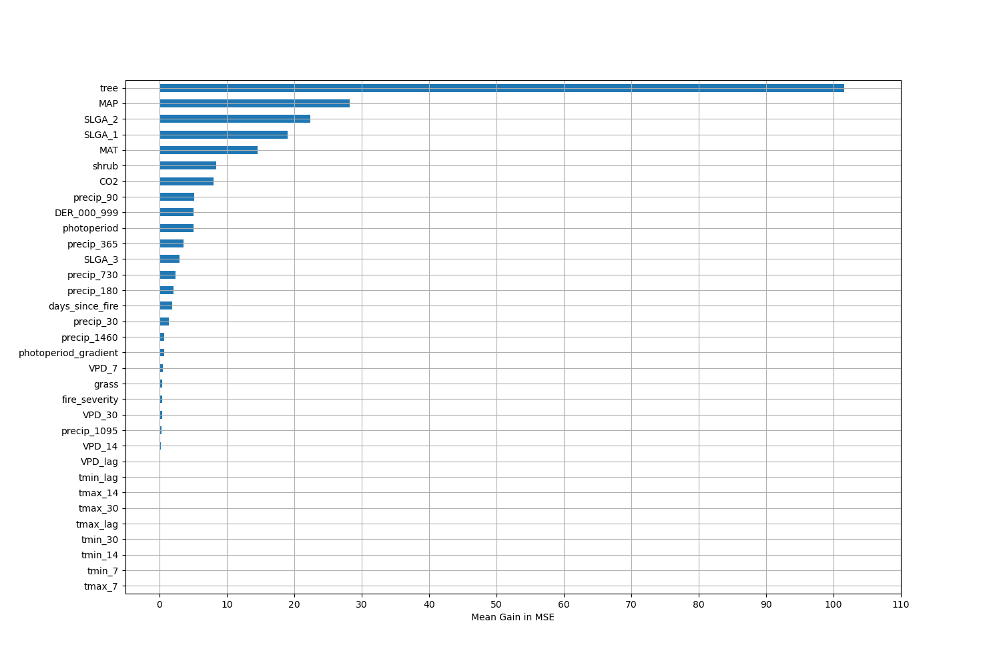

# Permutation Importance by Precip

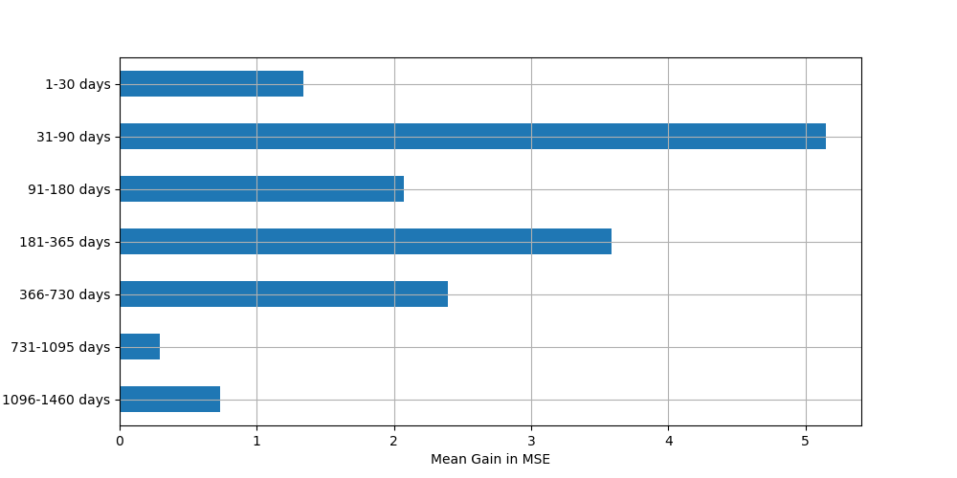

# ALE Importance

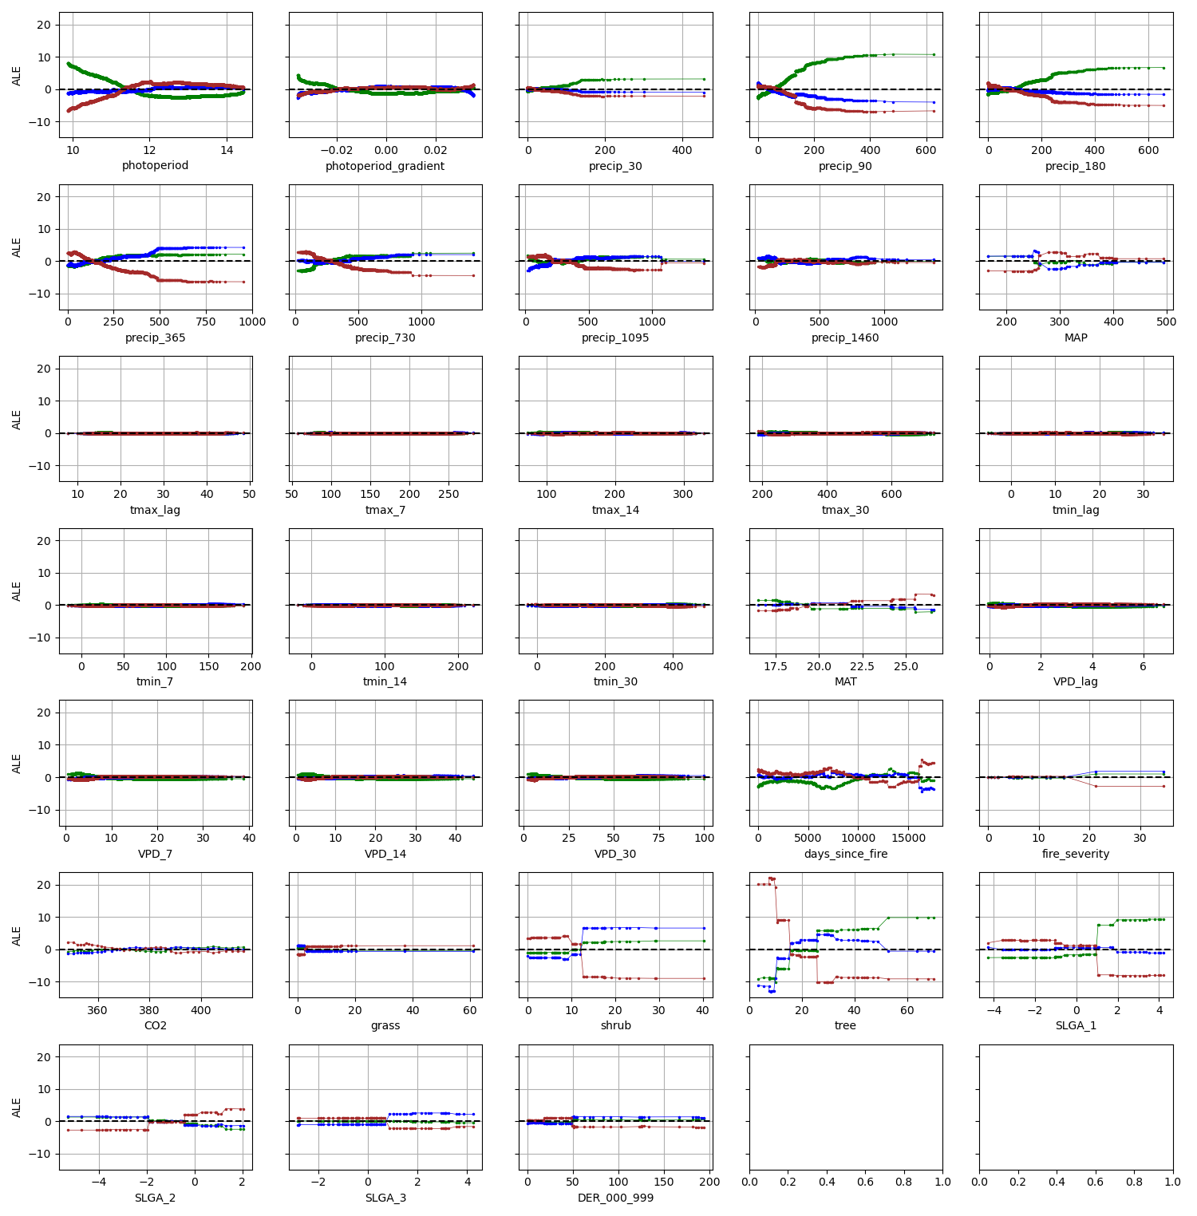

# NSABHC0028

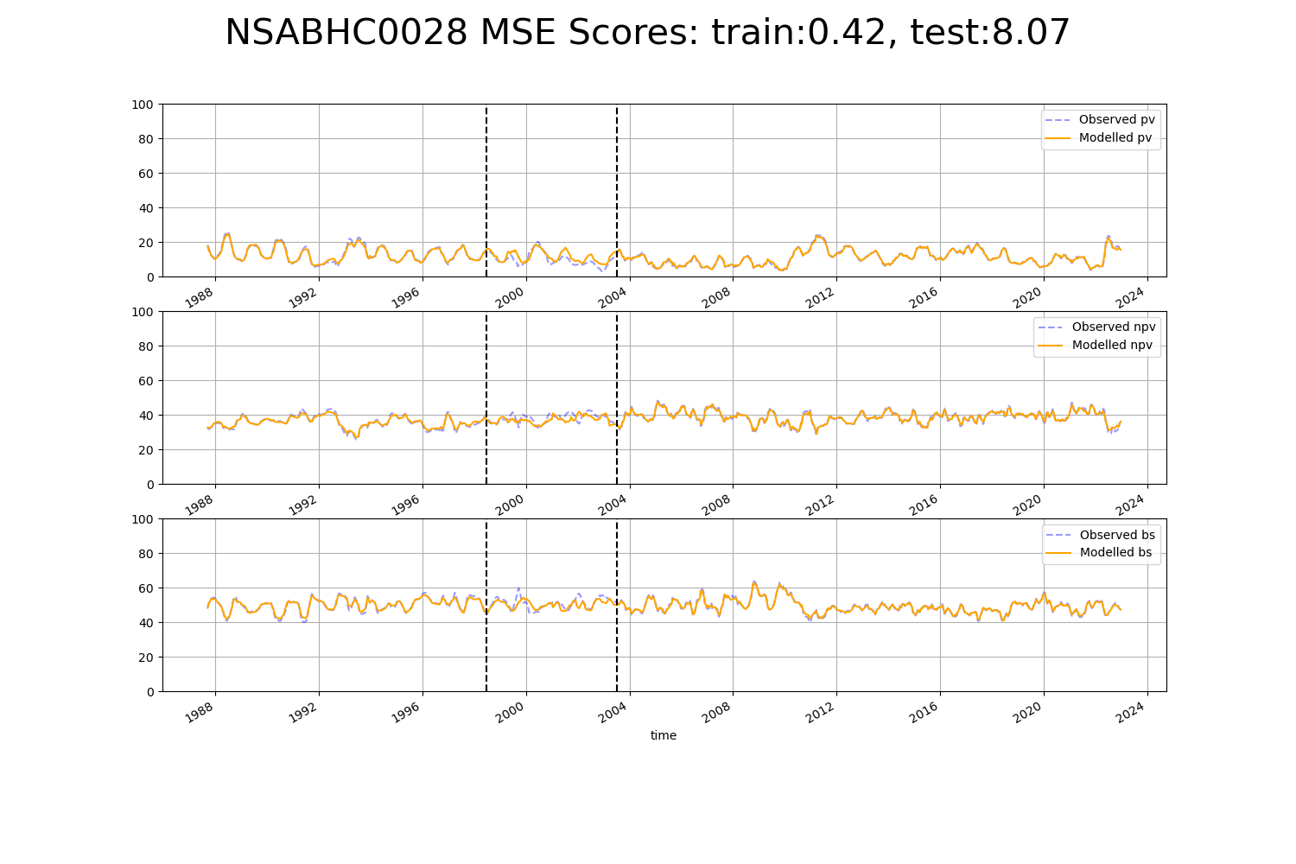

# NSABHC0029

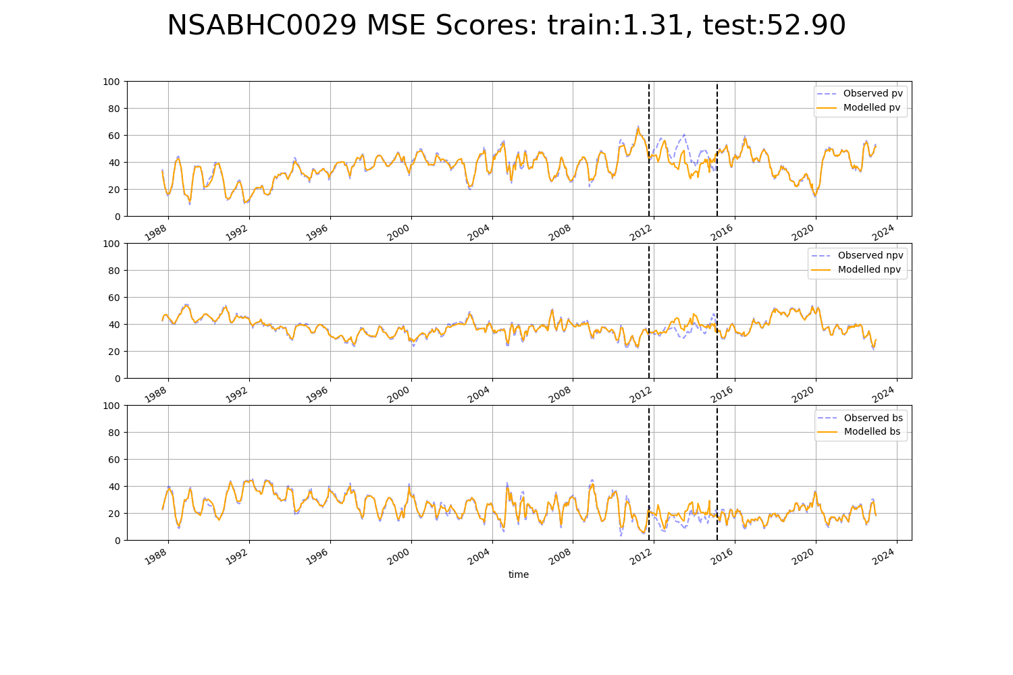

# NSACHC0002

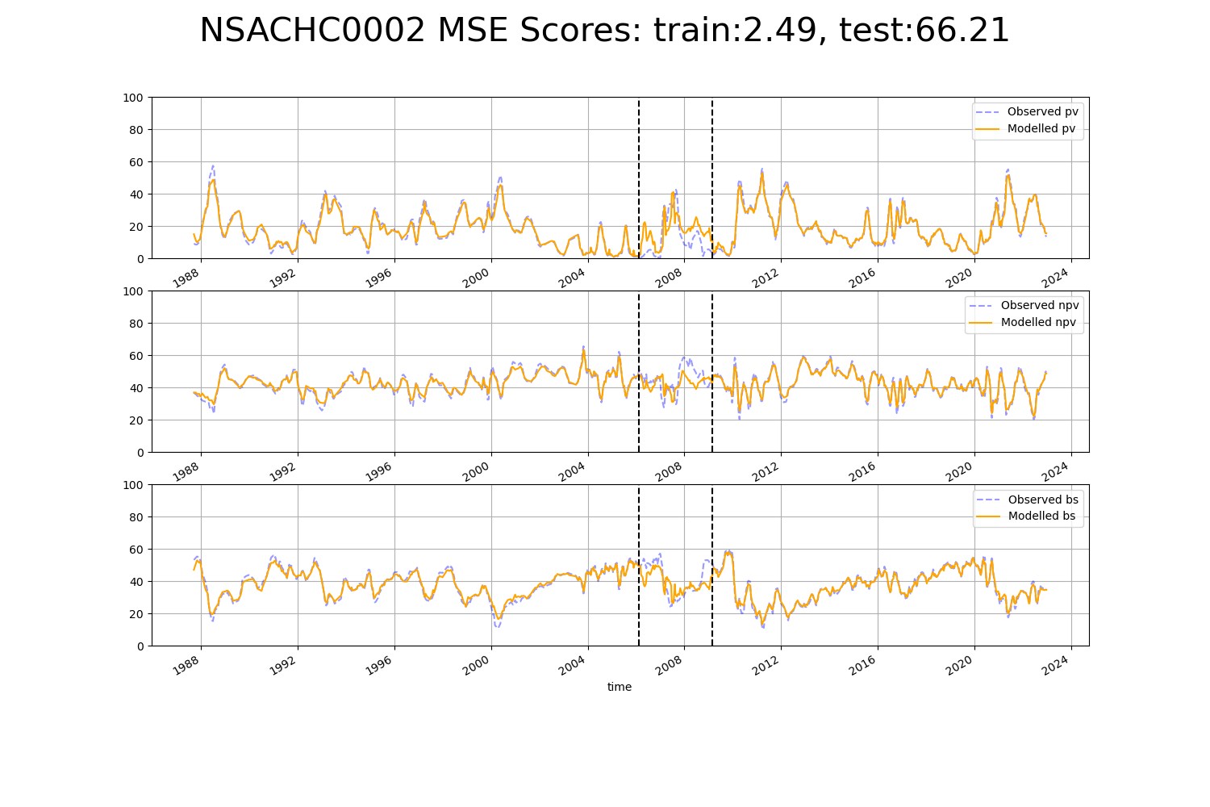

# NSACHC0003

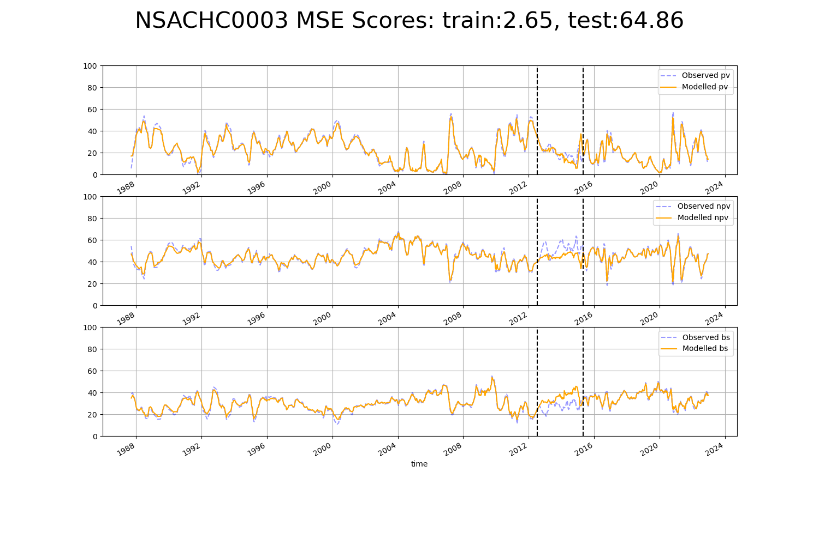

# NSACOP0001

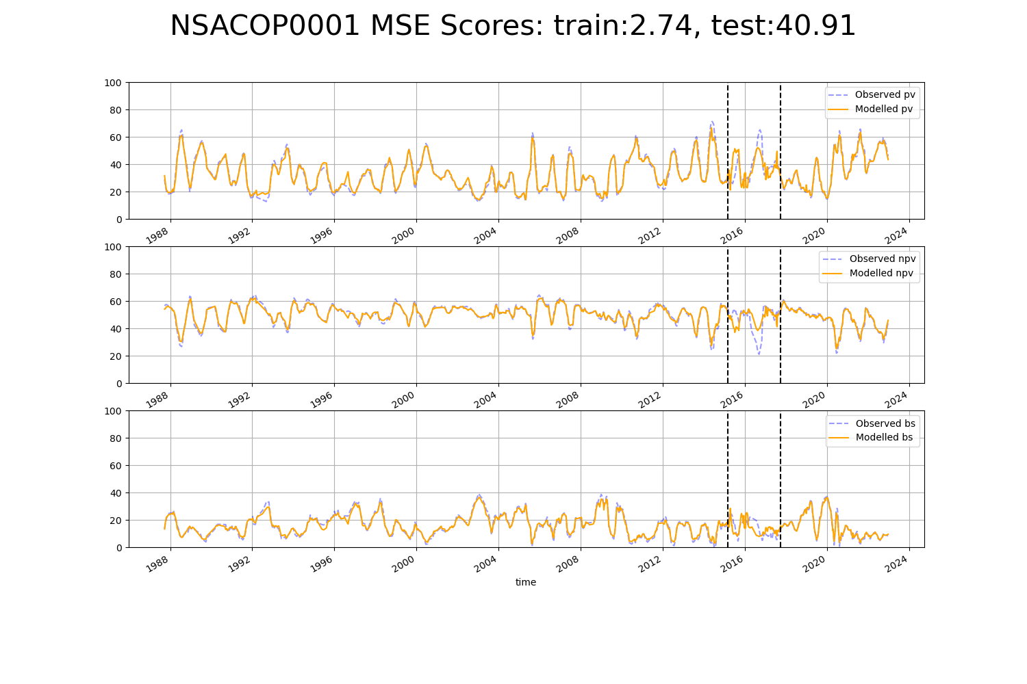

# NSACOP0002

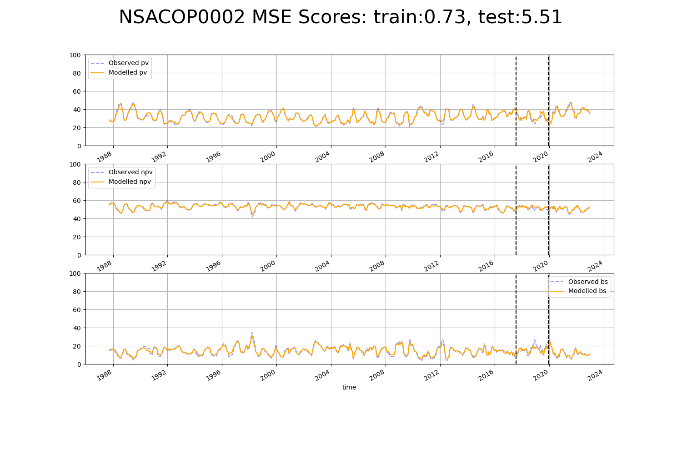

# NSAMDD0002

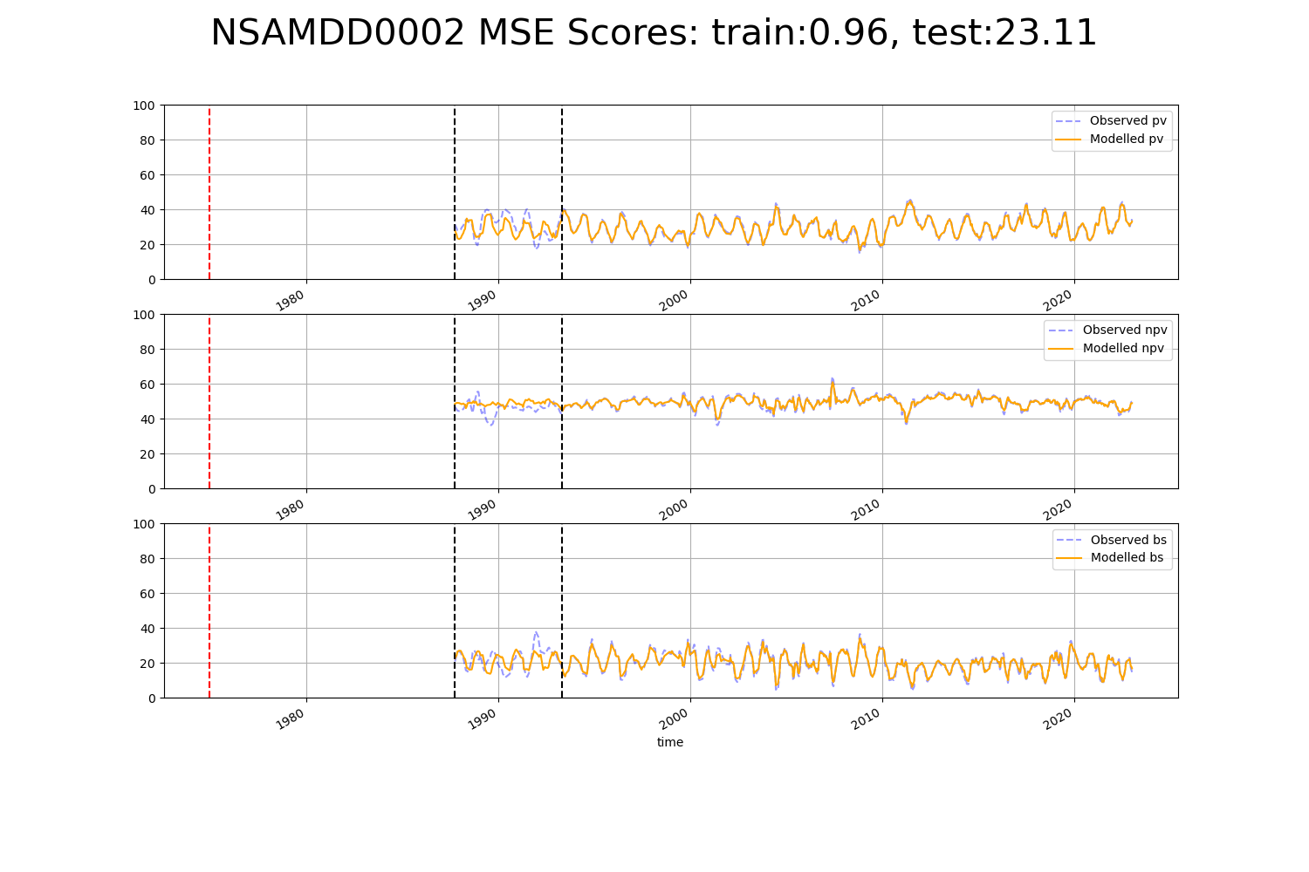

# NSAMDD0005

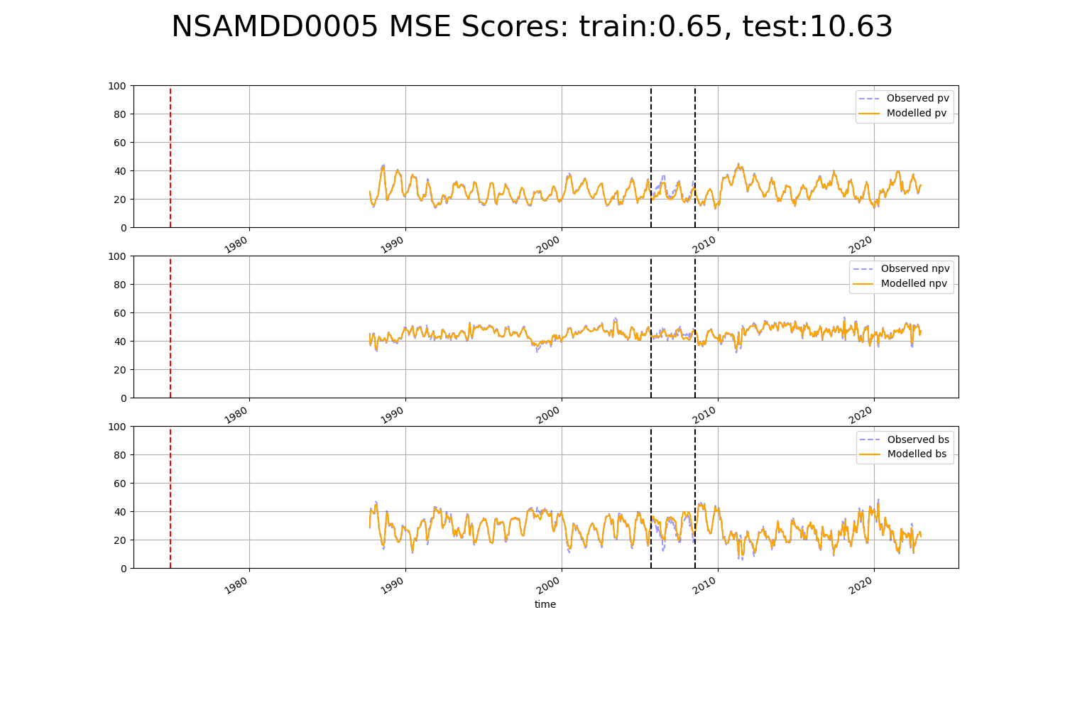

# NSAMDD0009

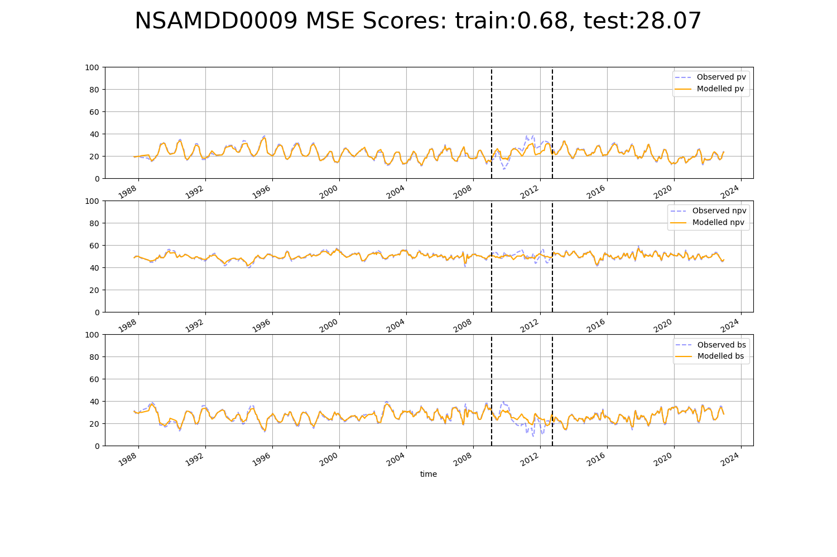

# NSAMDD0011

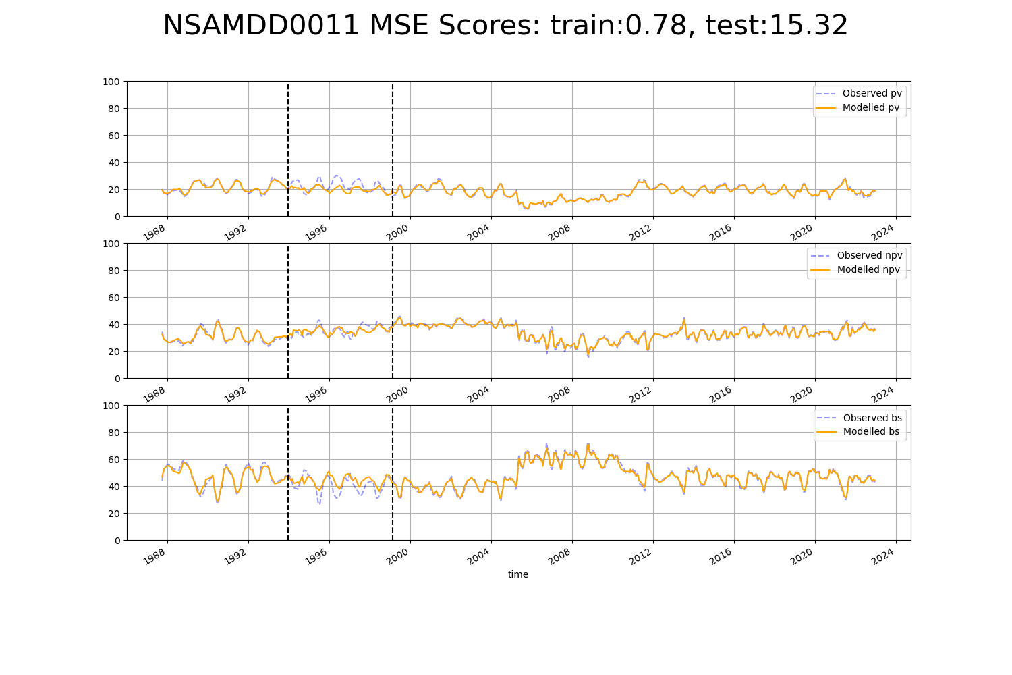

# NSAMDD0013

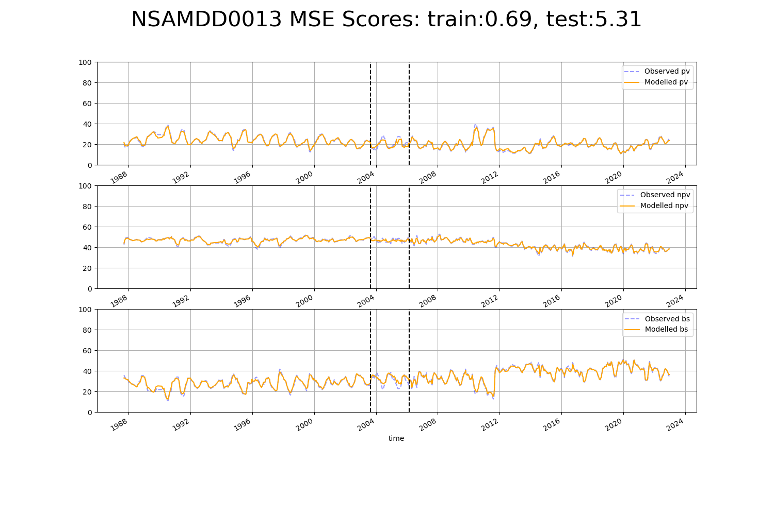

# NSAMDD0015

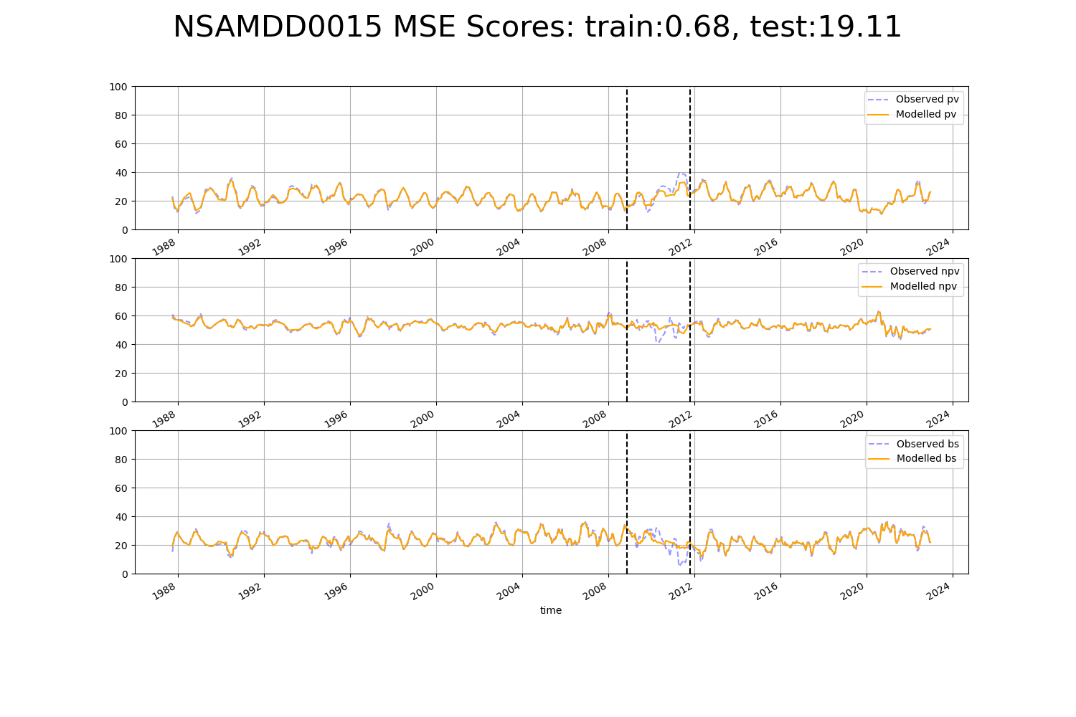

# NSAMDD0017

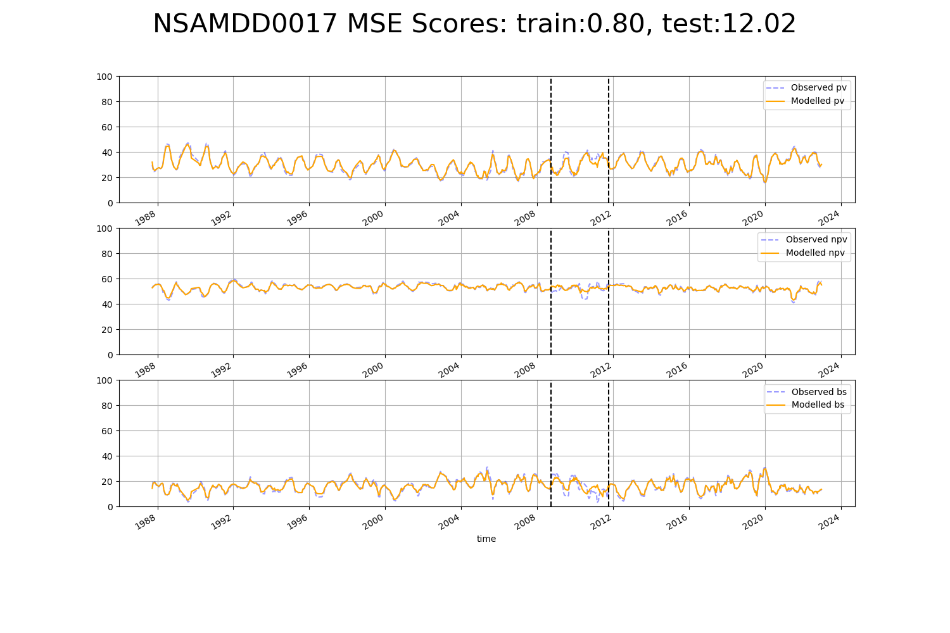

# NSAMDD0018

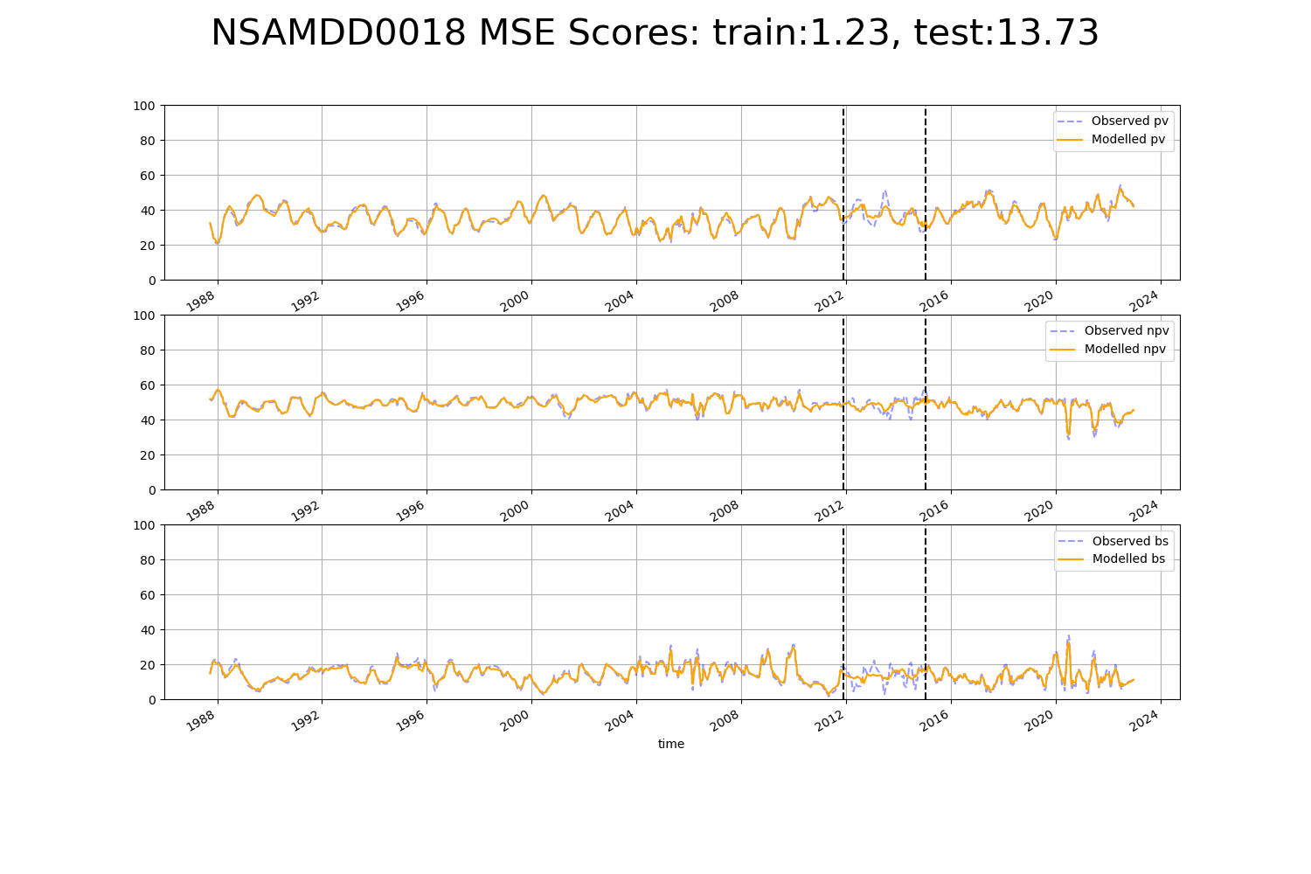

# NSAMDD0020

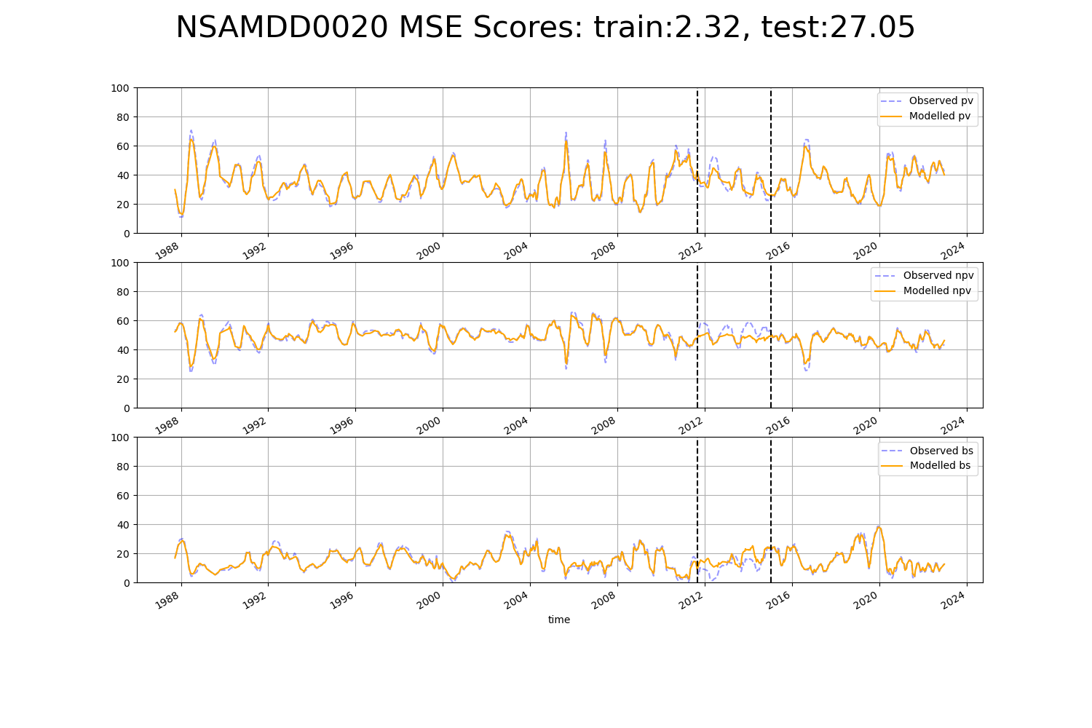

# NSAMDD0025

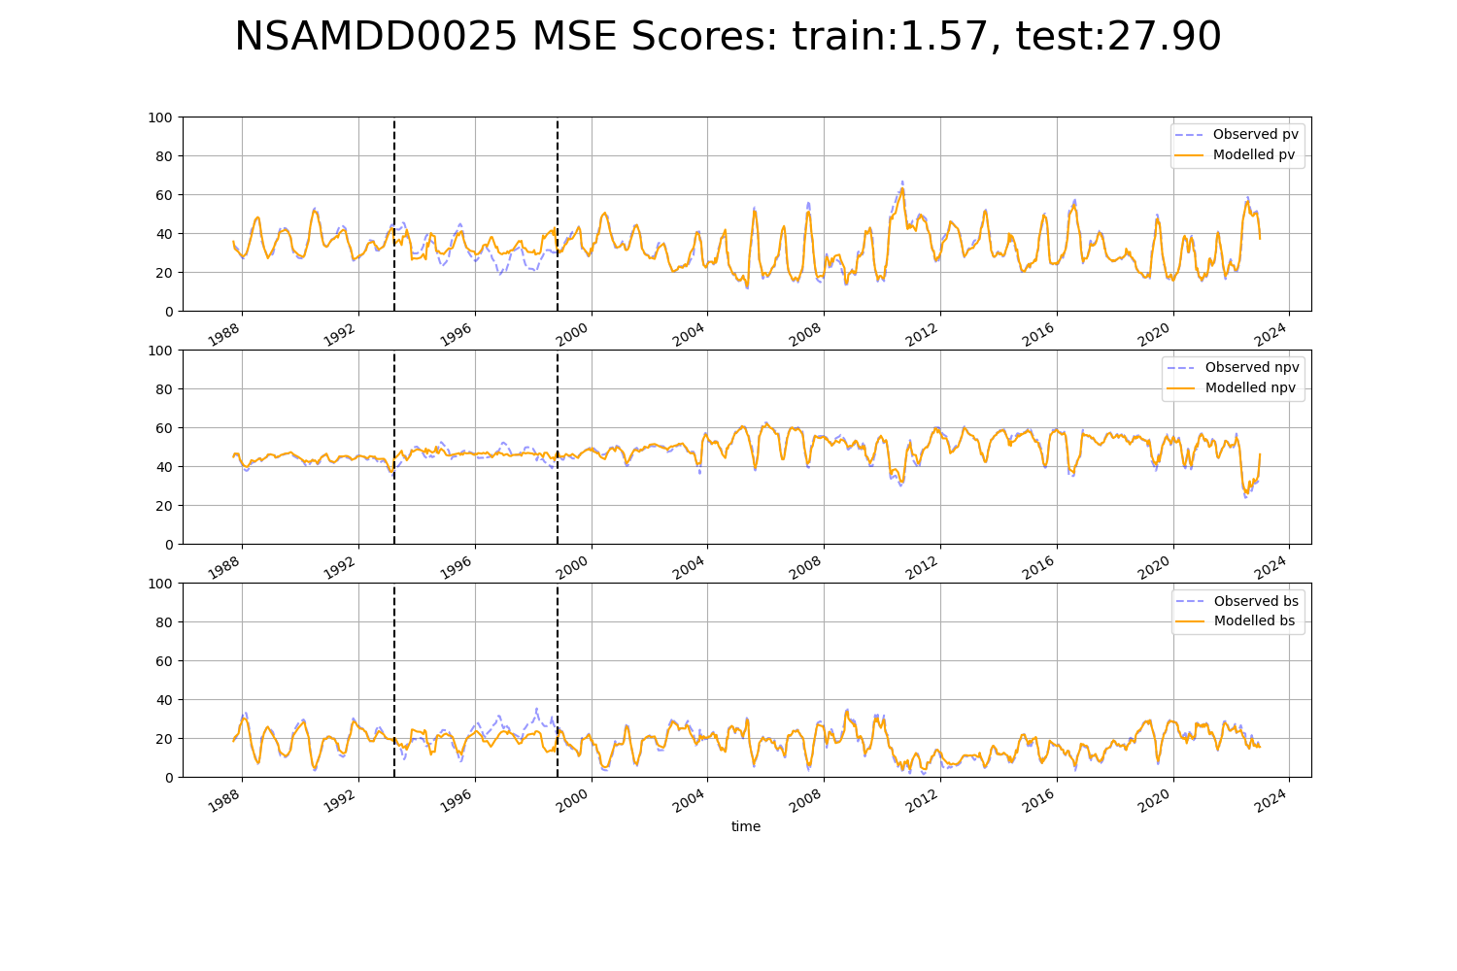

# NSAMDD0027

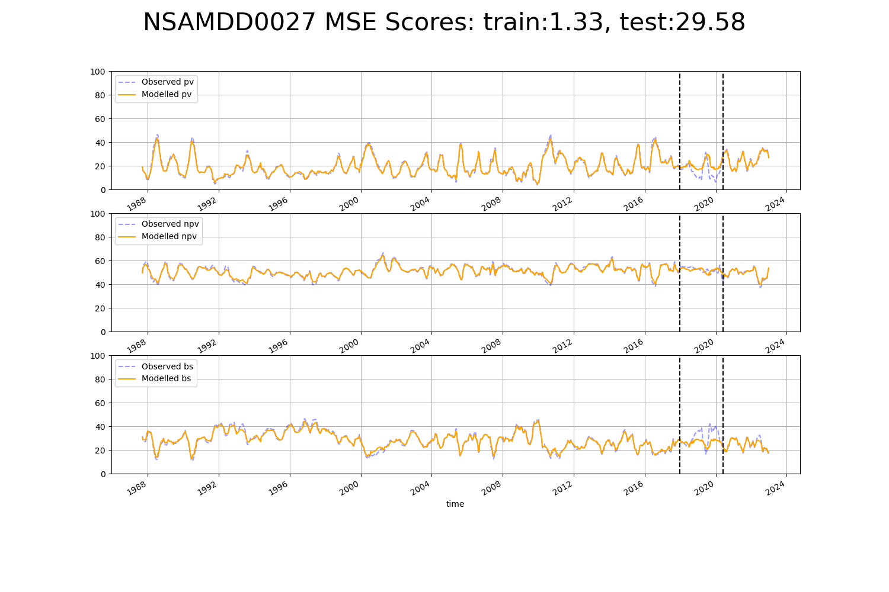

# NSAMDD0030

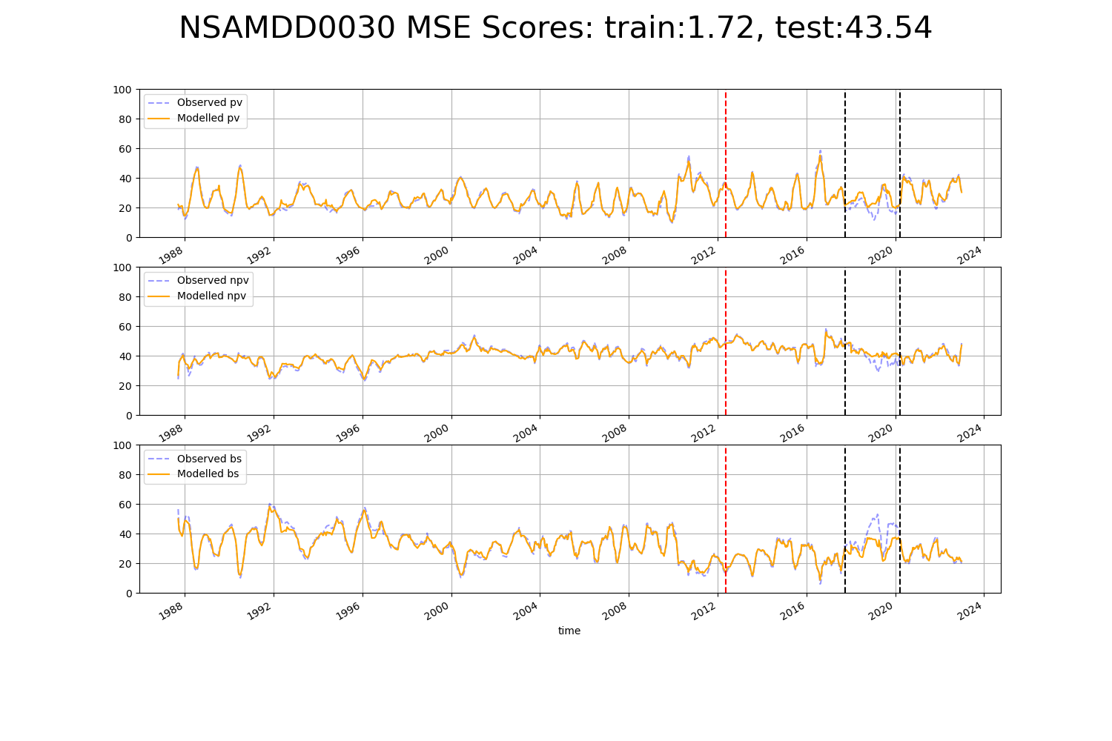

# NSAMDD0032

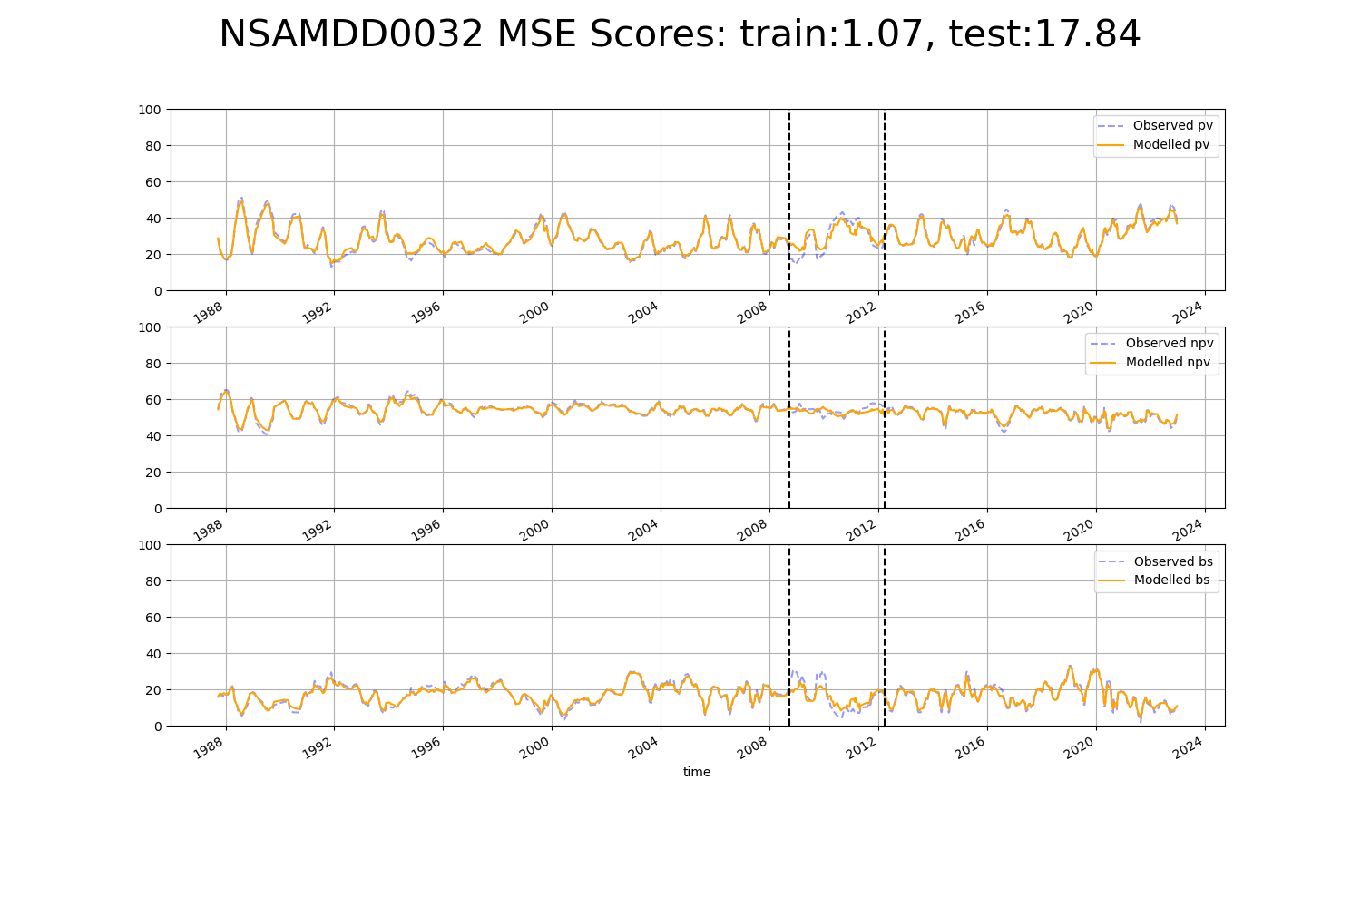

# NSAMUL0002

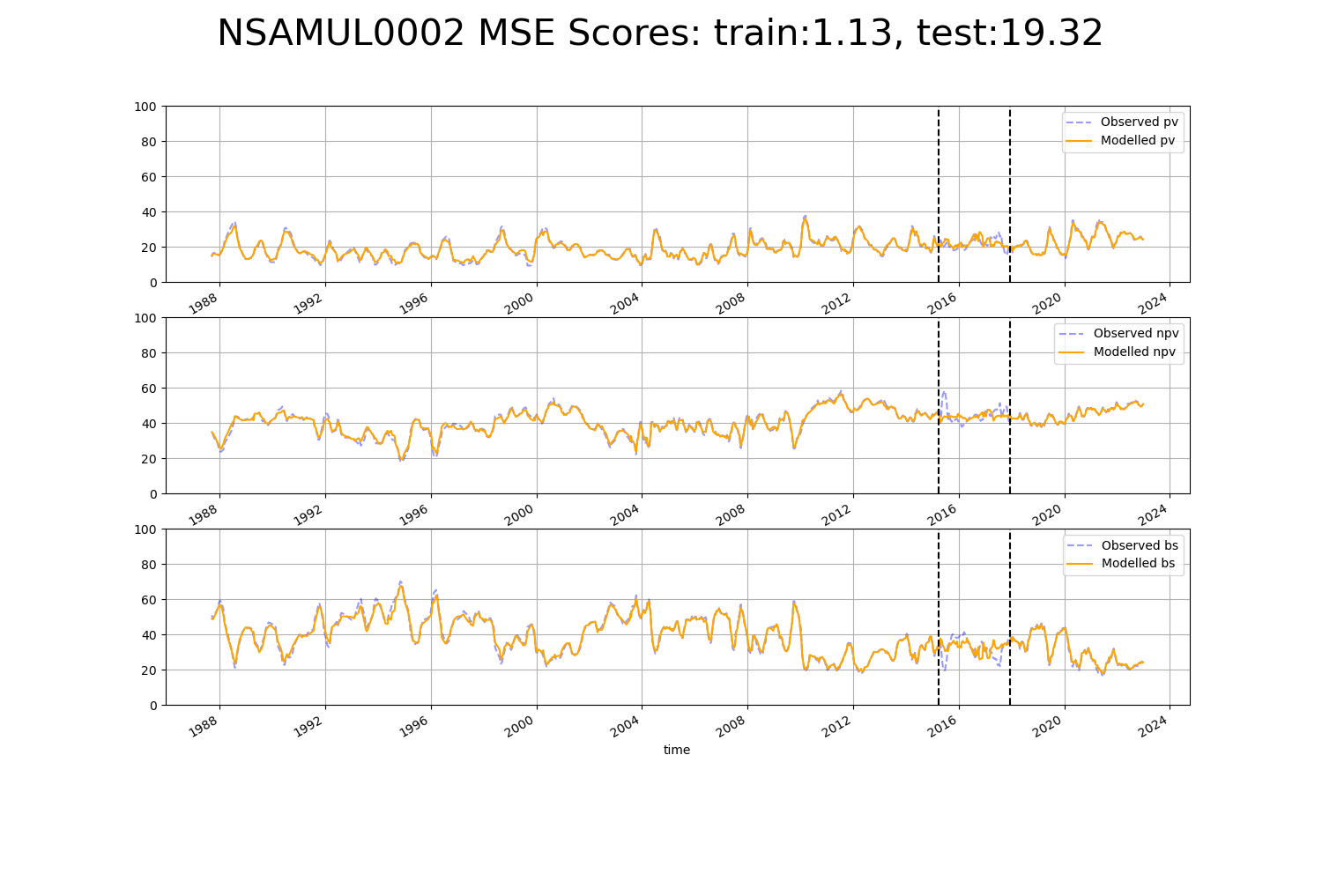

# NSAMUL0003

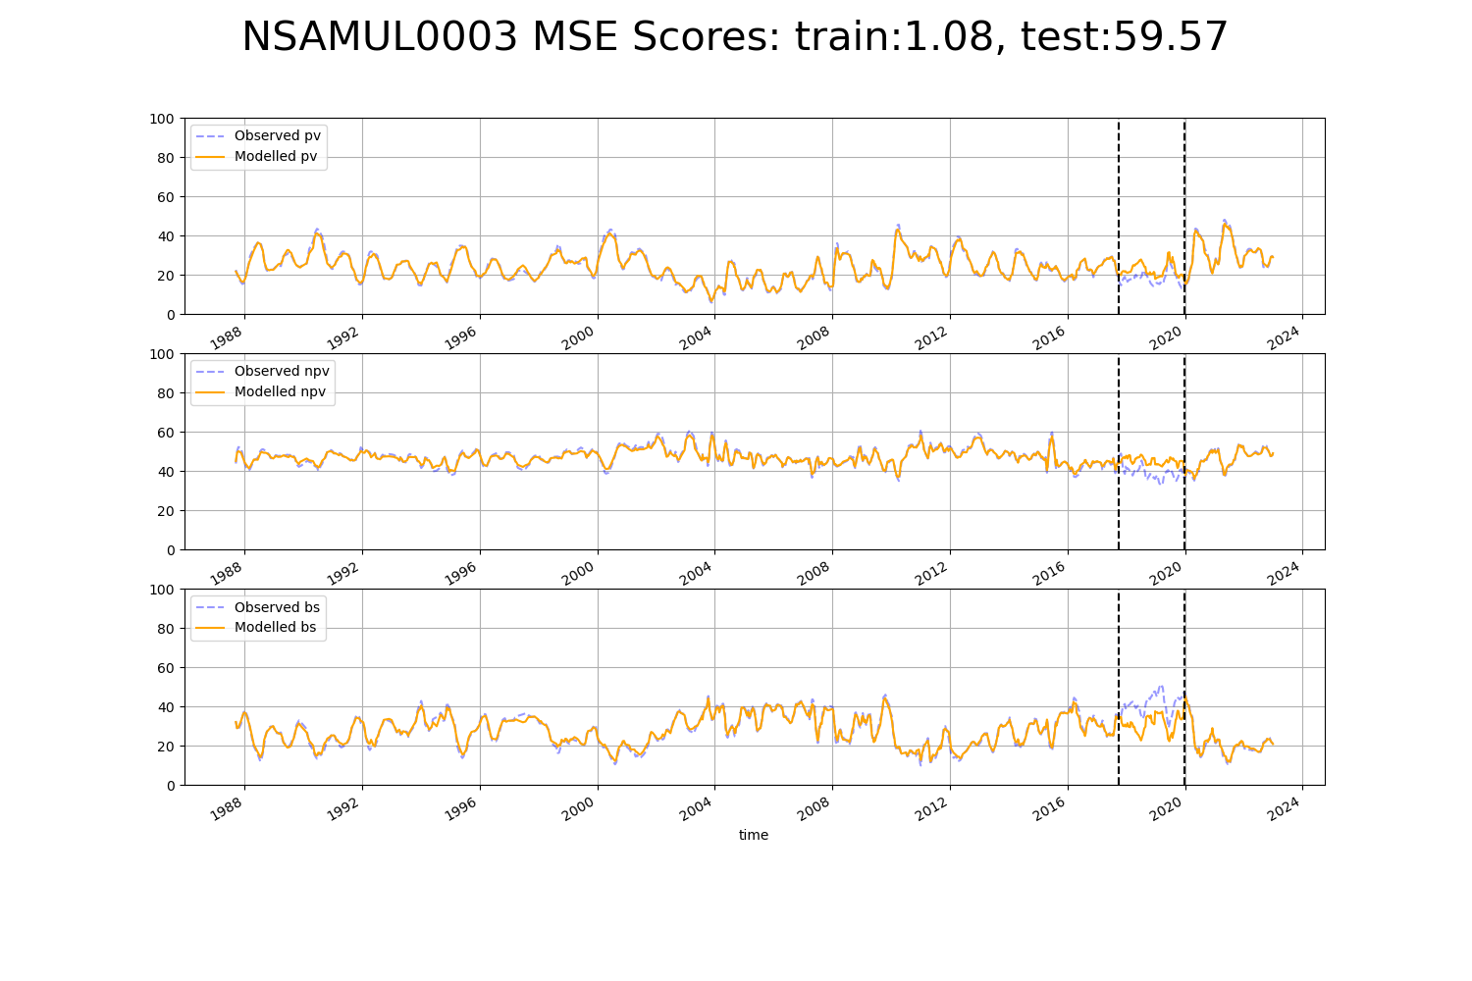

# NSAMUL0004

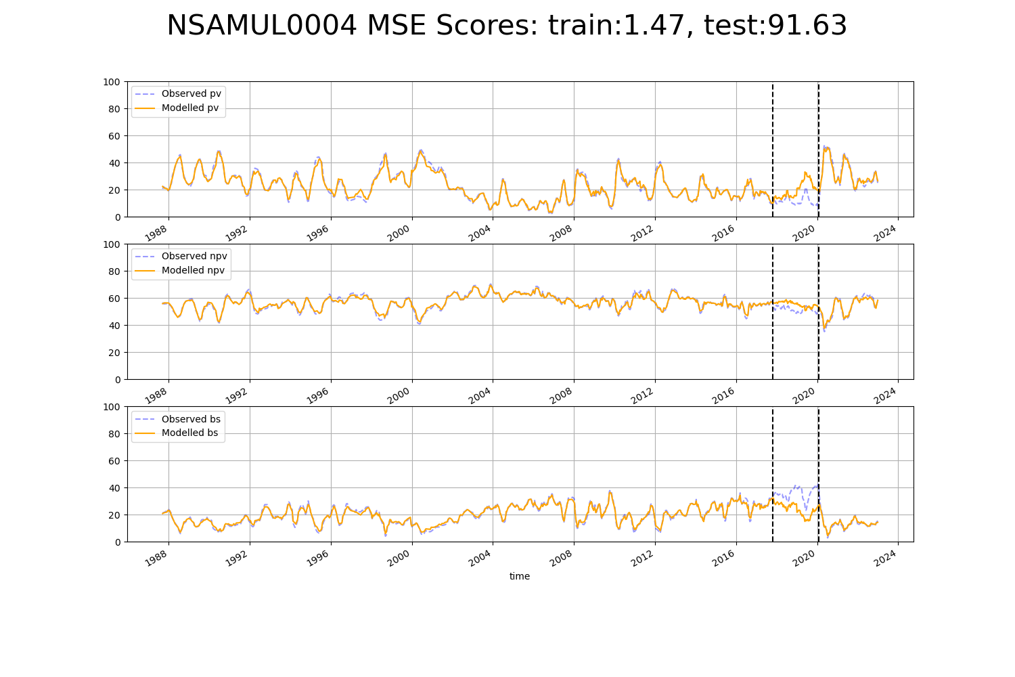

# NTAFIN0003

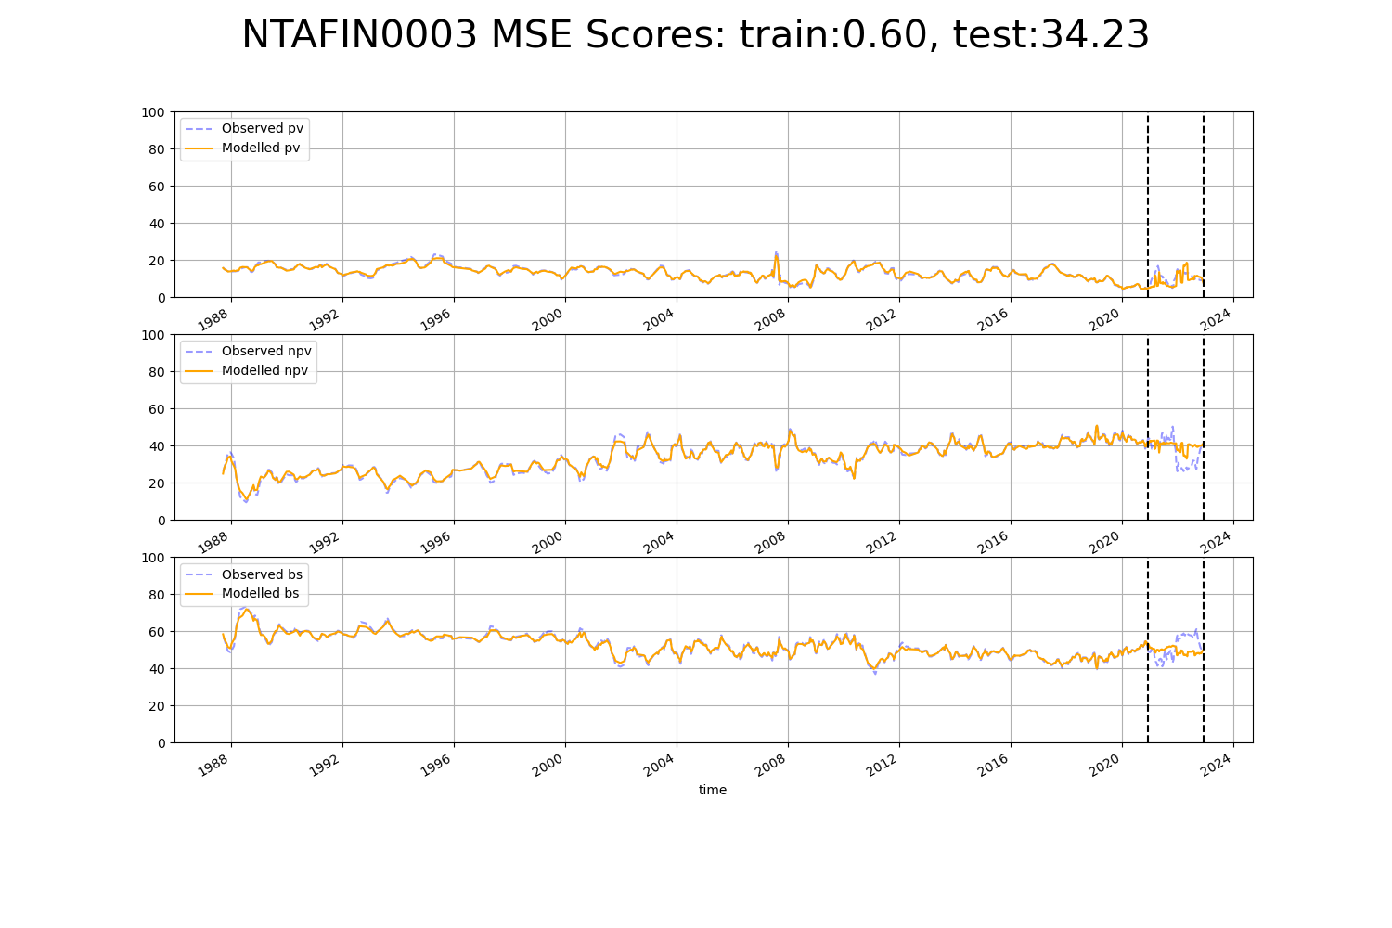

# NTAFIN0013

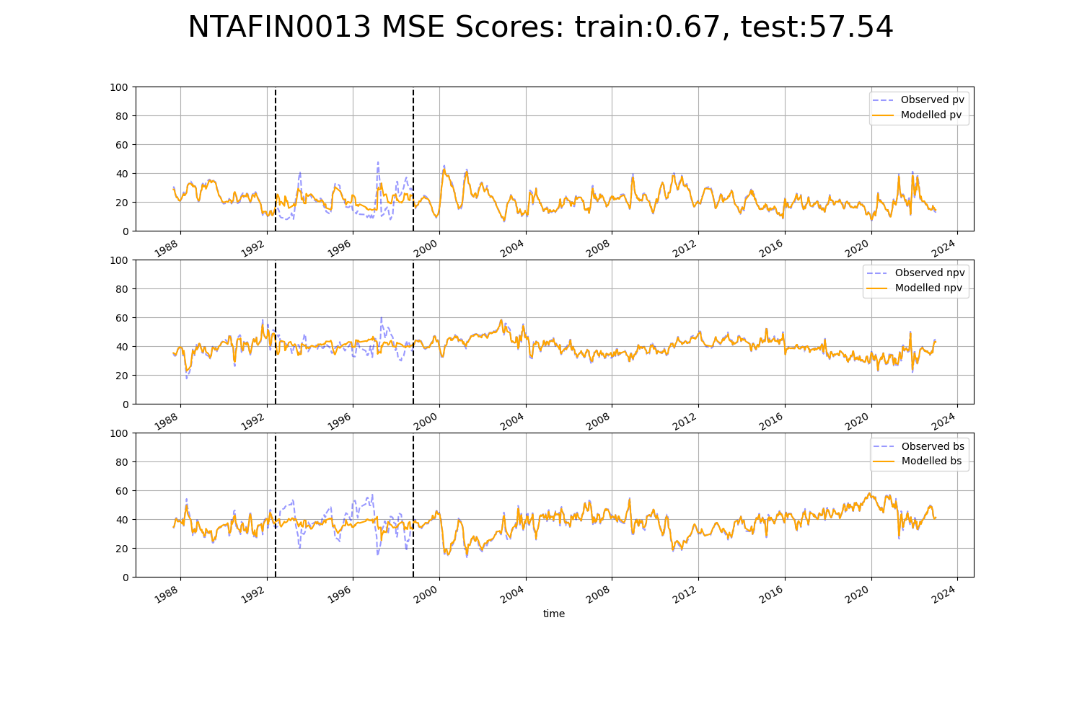

# NTAFIN0015

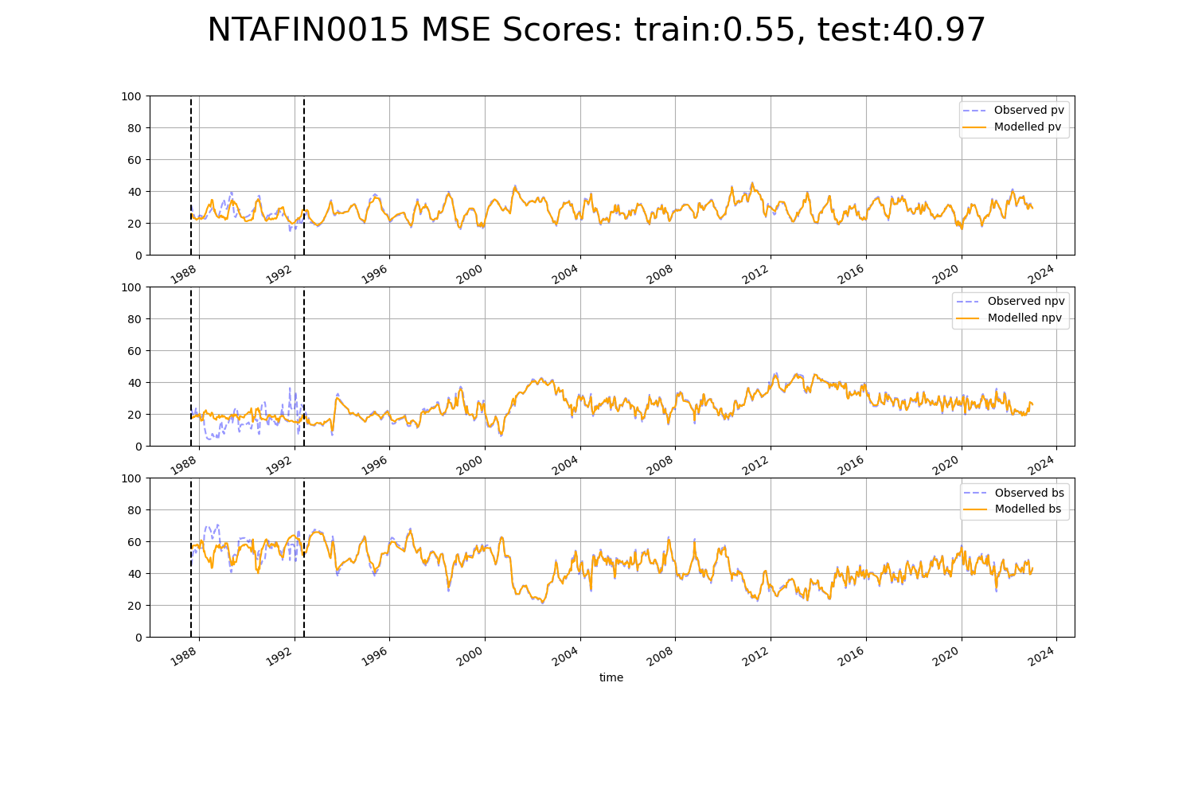

# NTAFIN0024

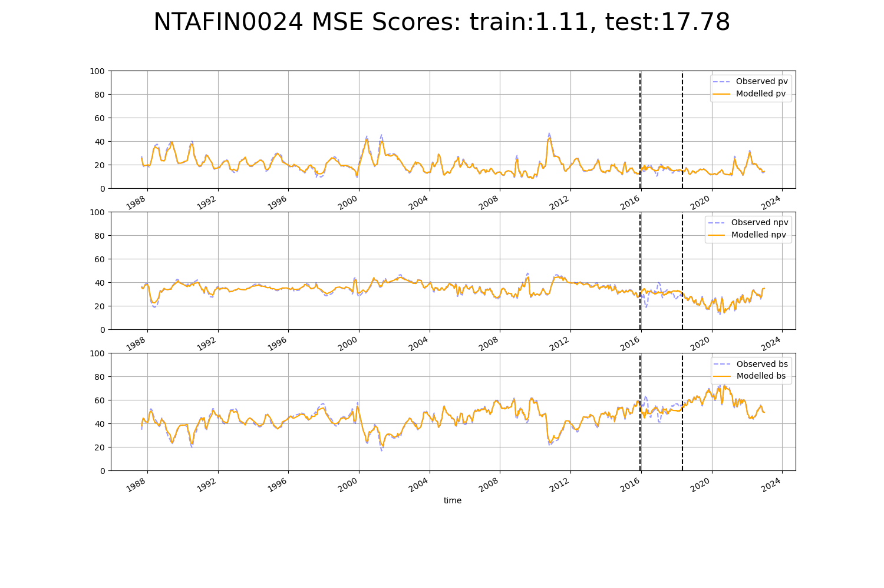

# NTAMAC0002

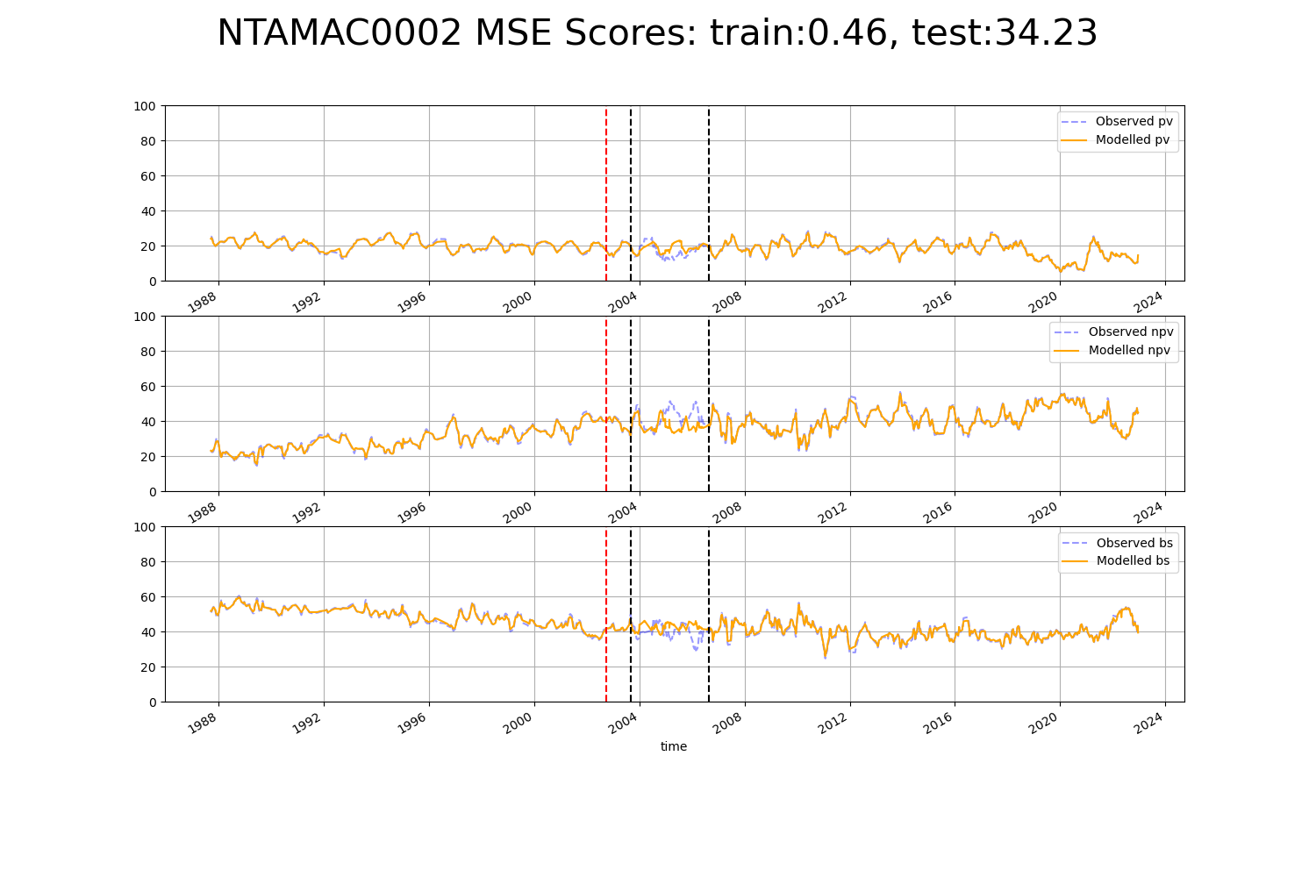

# QDACHC0001

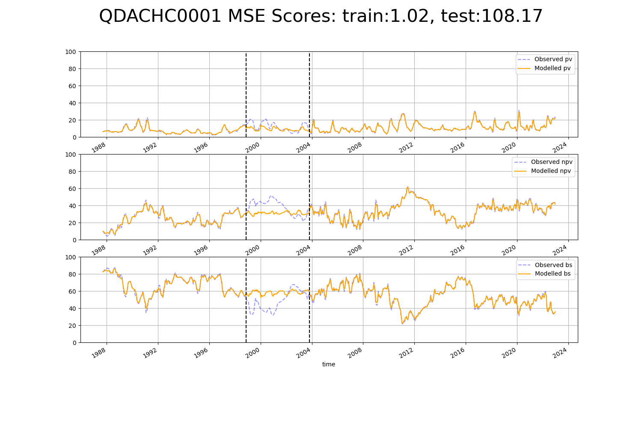

# QDACHC0002

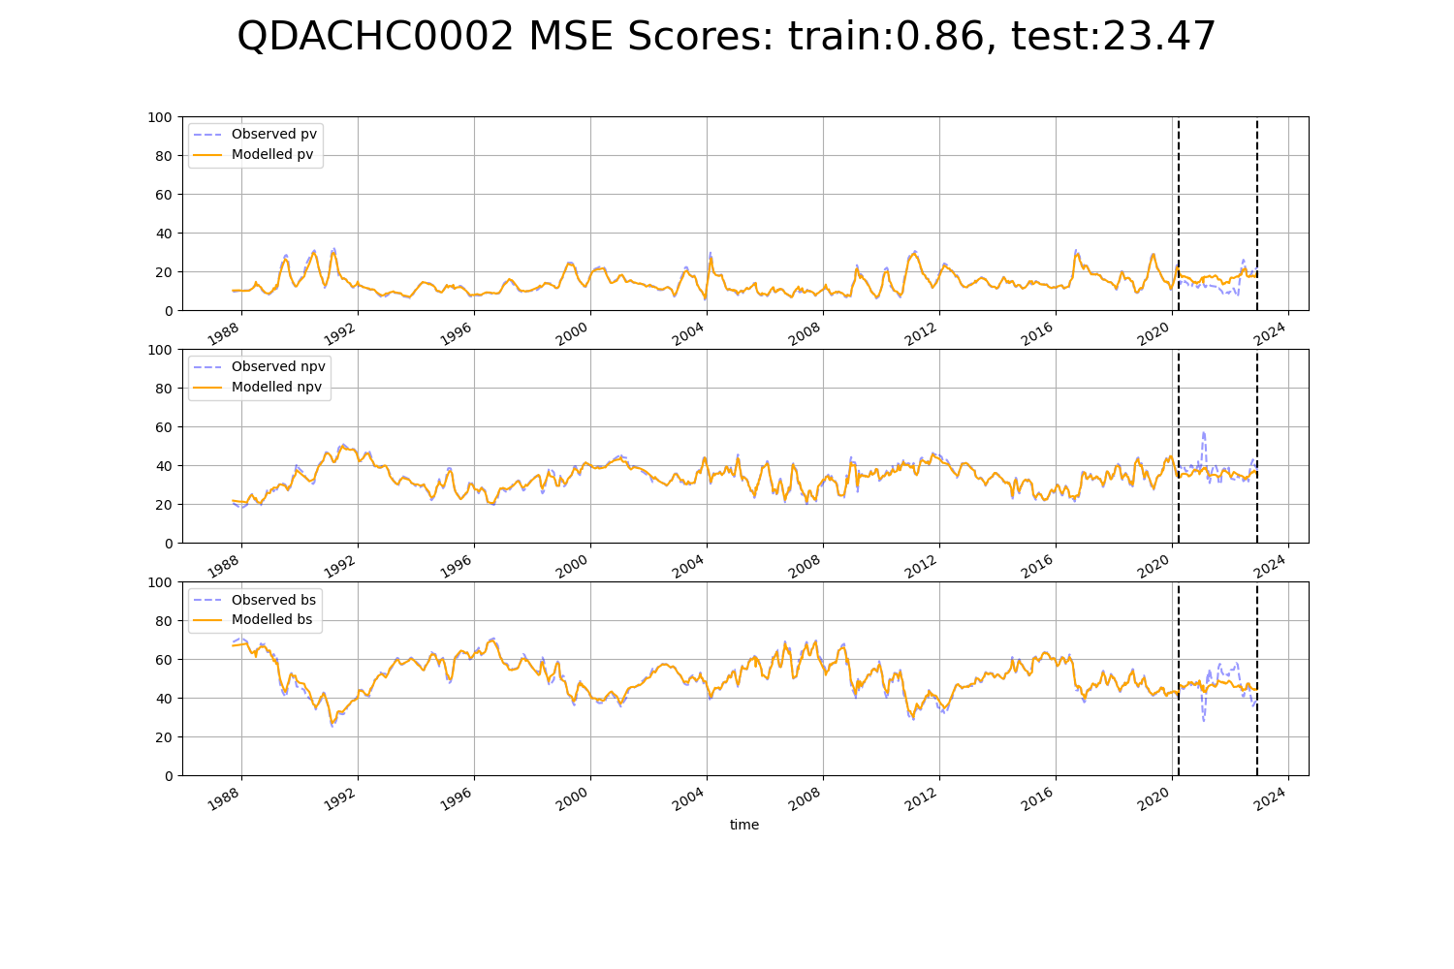

# QDACHC0003

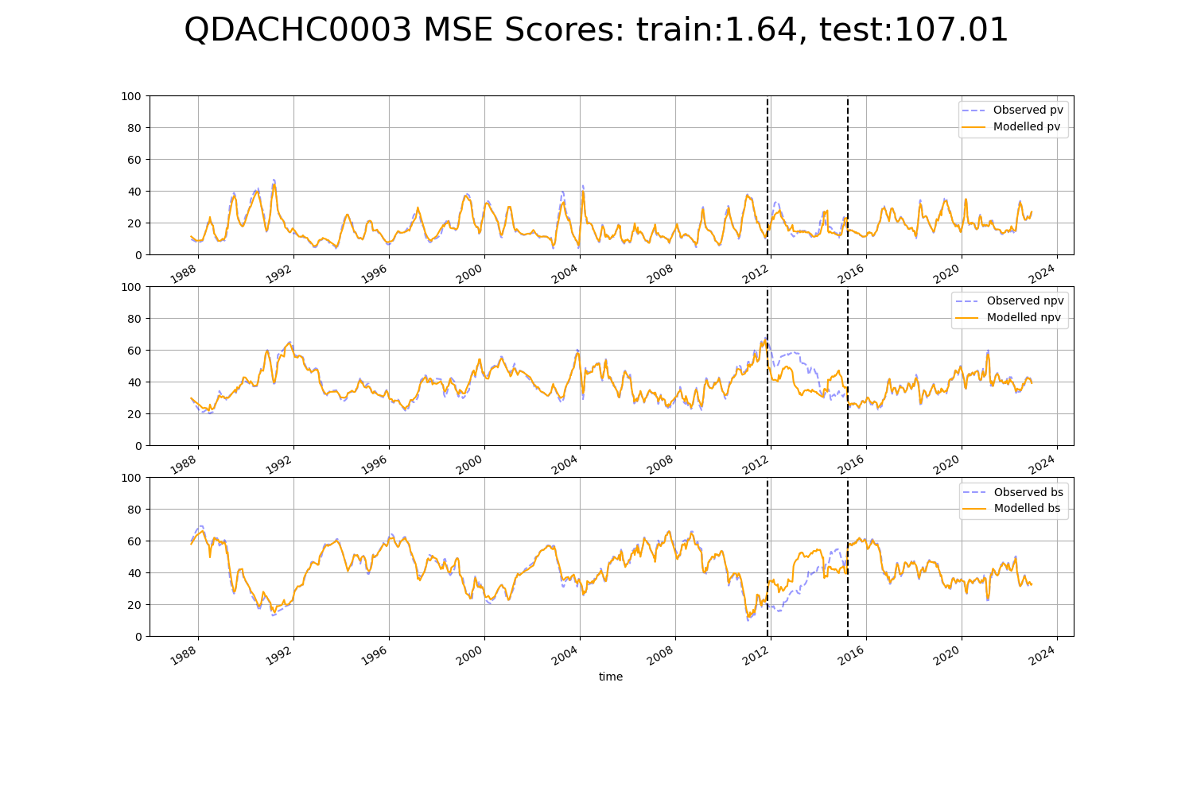

# QDAMGD0015

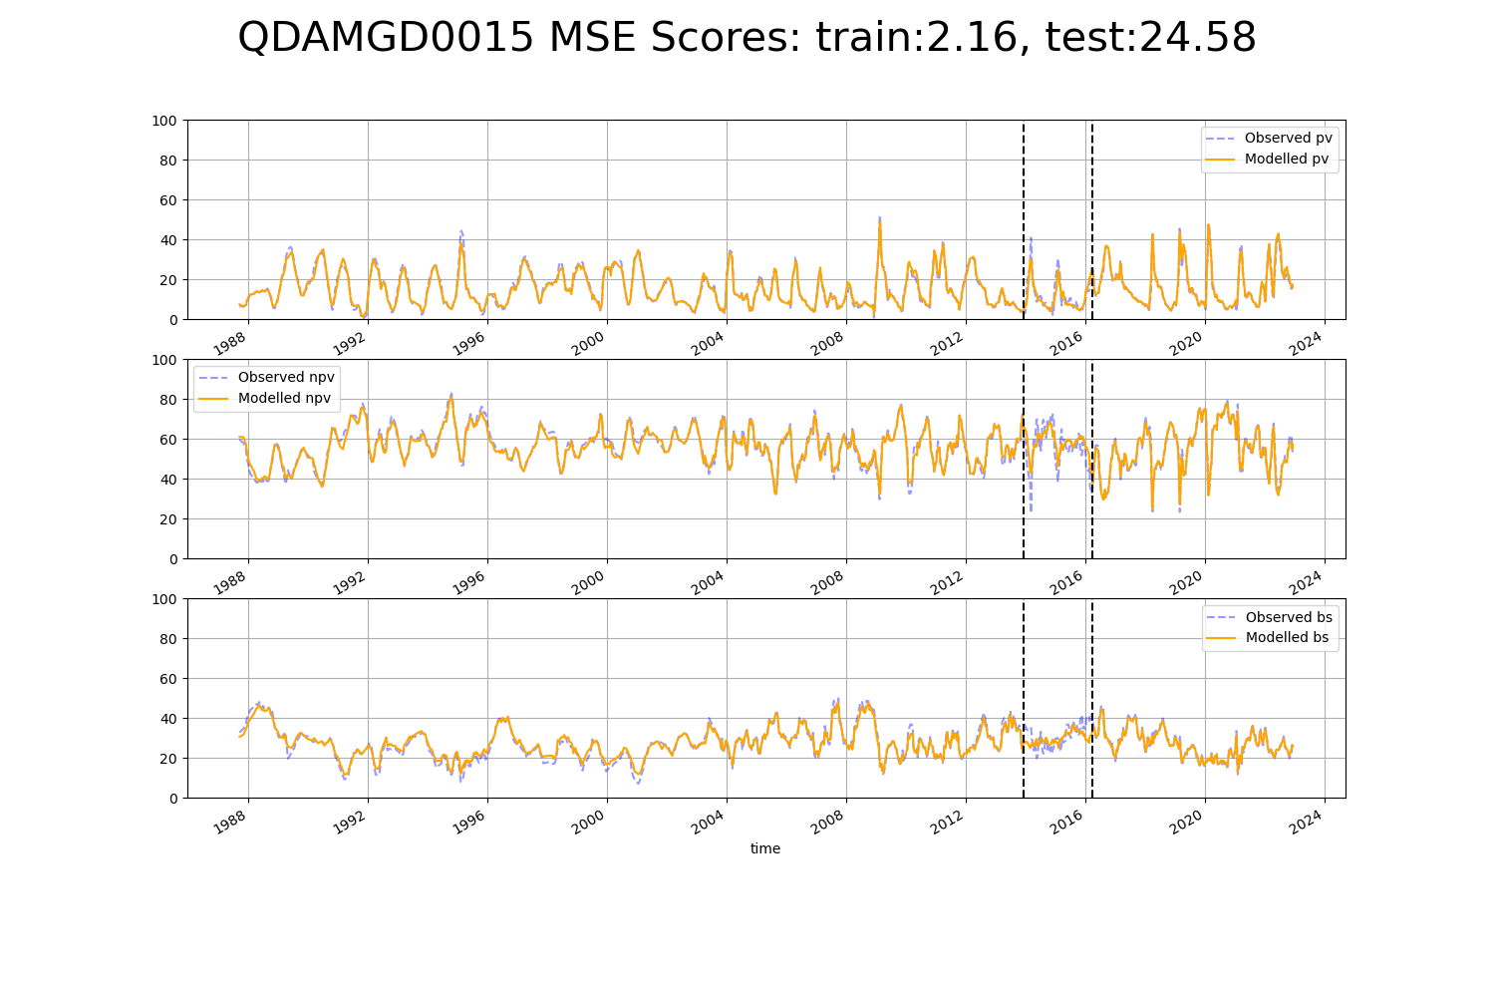

# QDAMGD0016

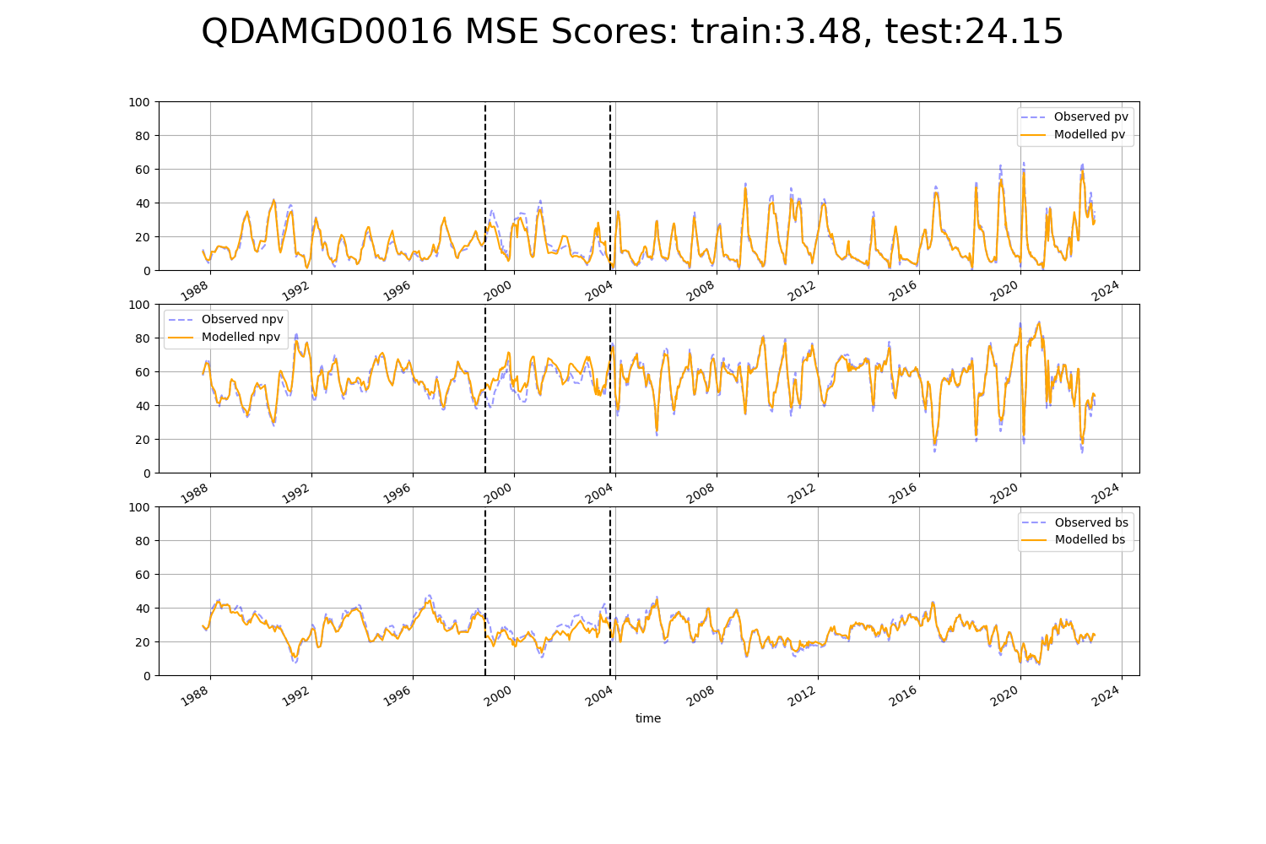

# QDAMGD0020

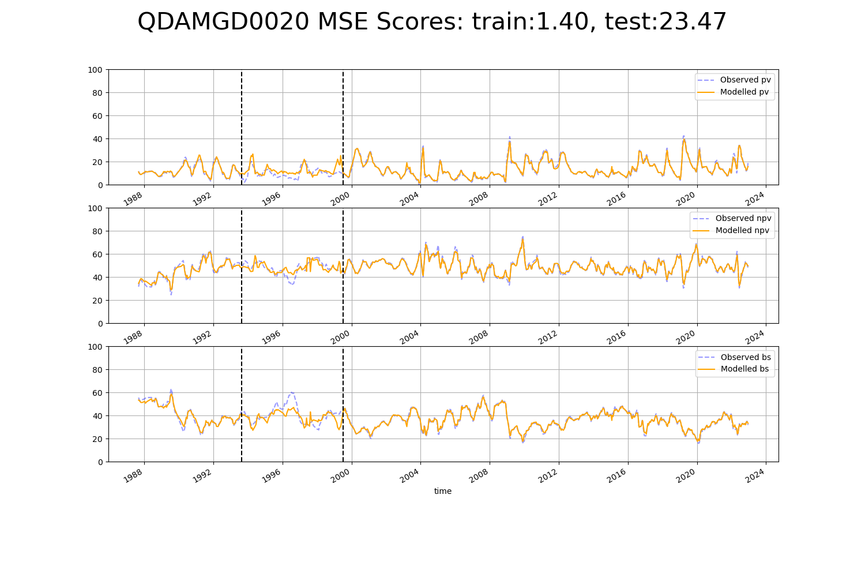

# QDAMUL0001

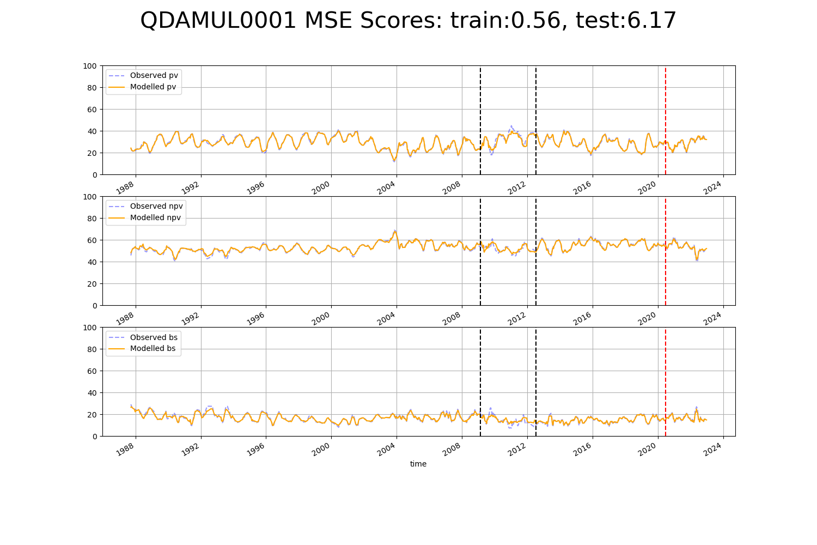

# QDAMUL0002

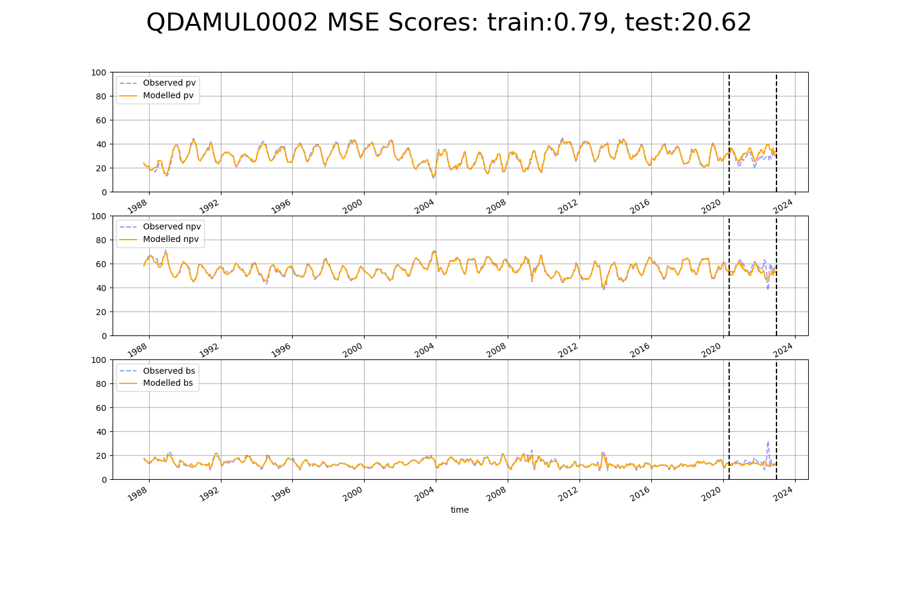

# QDAMUL0003

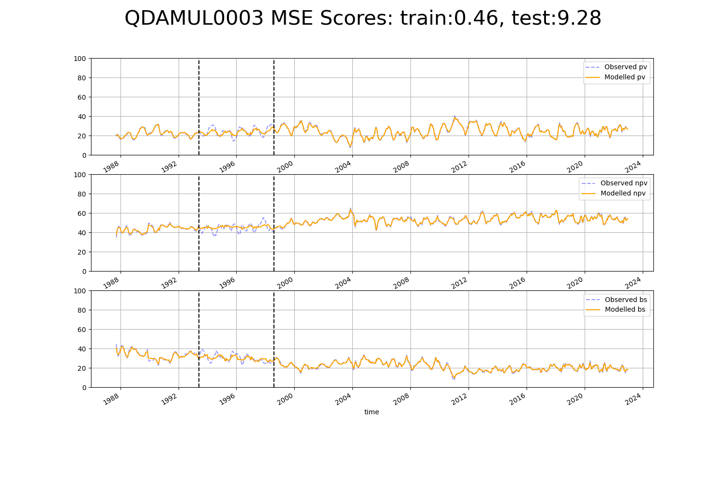

# QDASSD0005

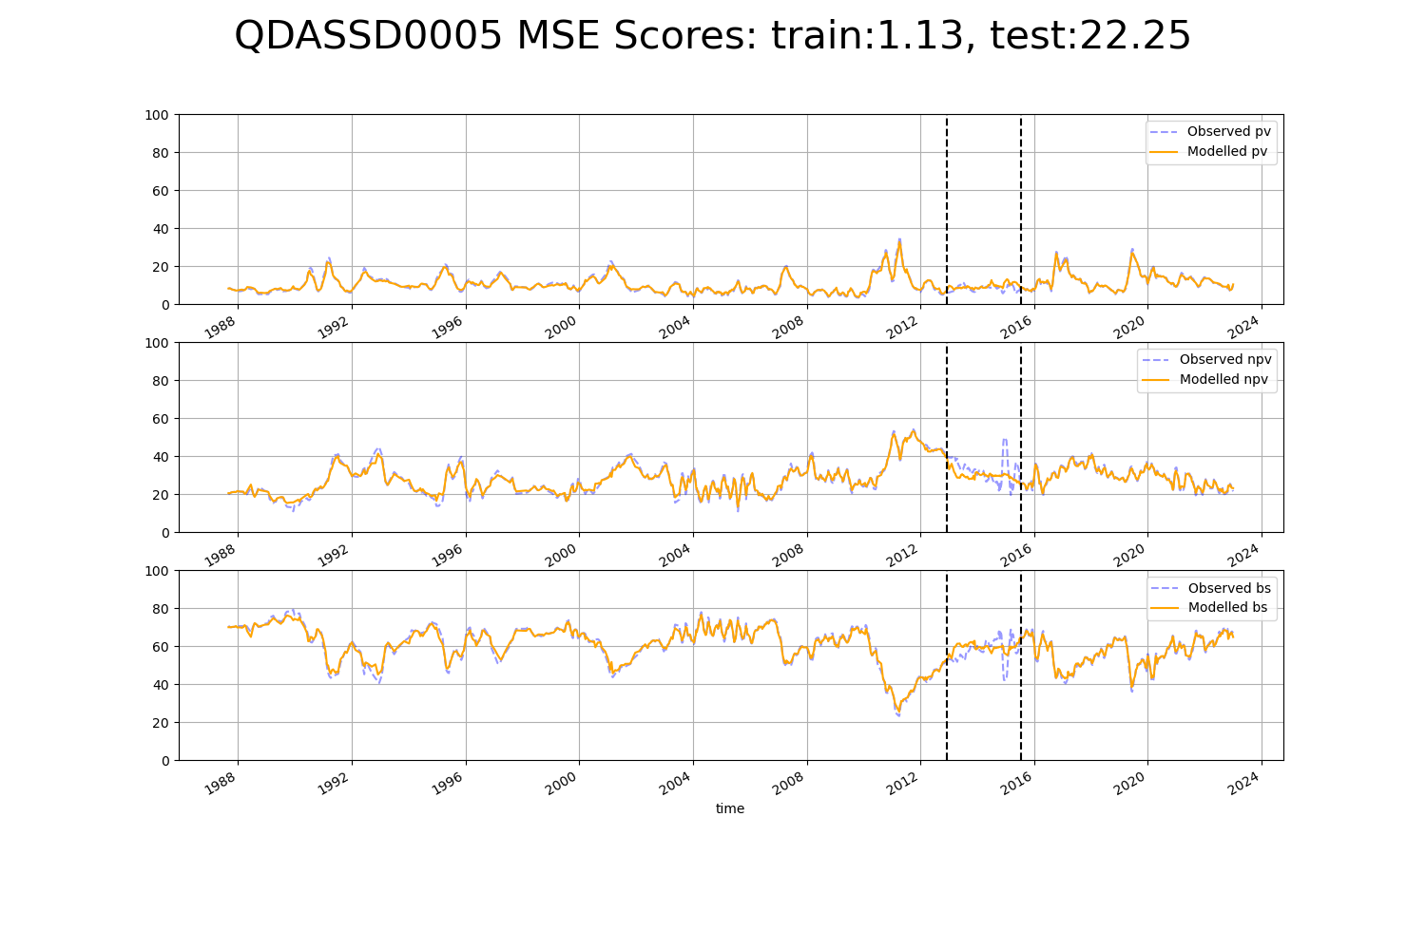

# QDASSD0011

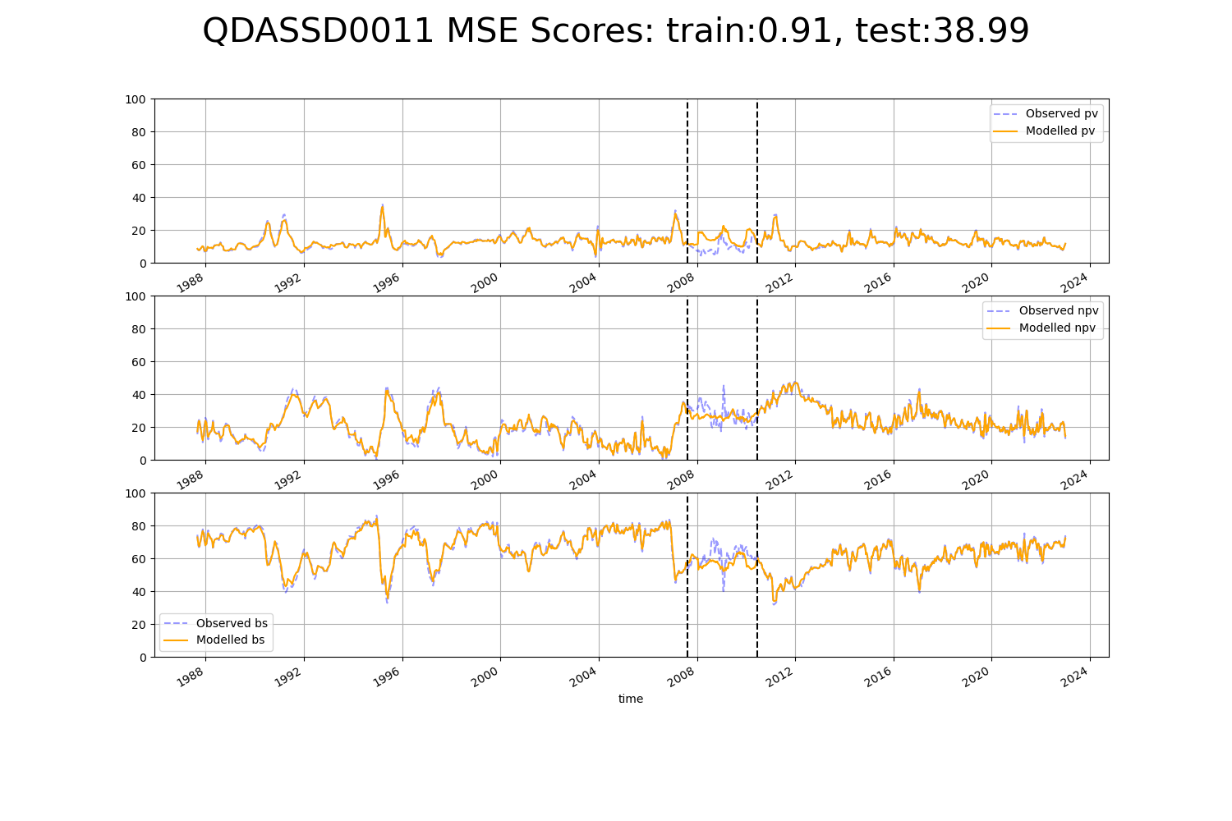

# SAABHC0004

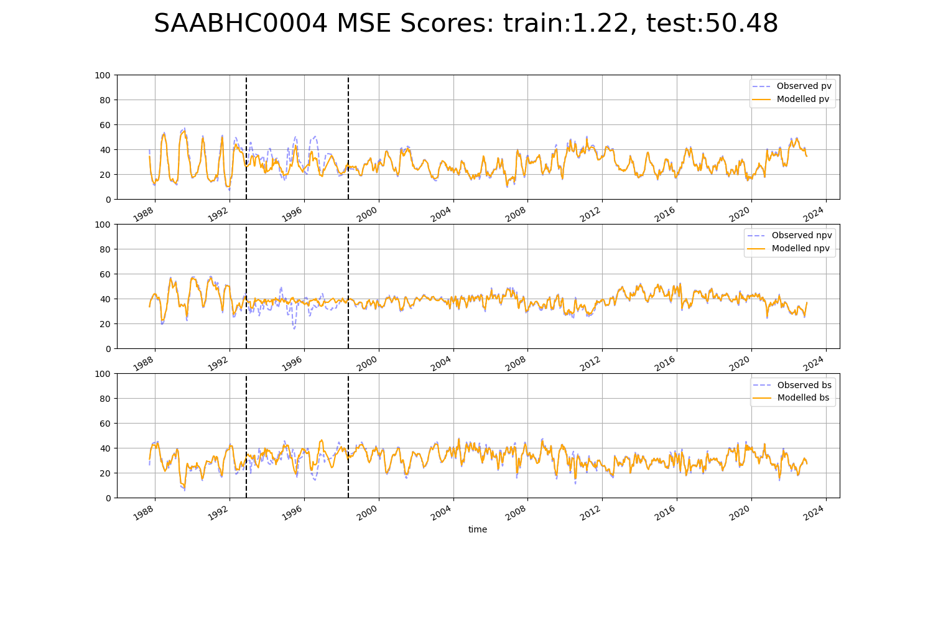

# SAAFLB0008

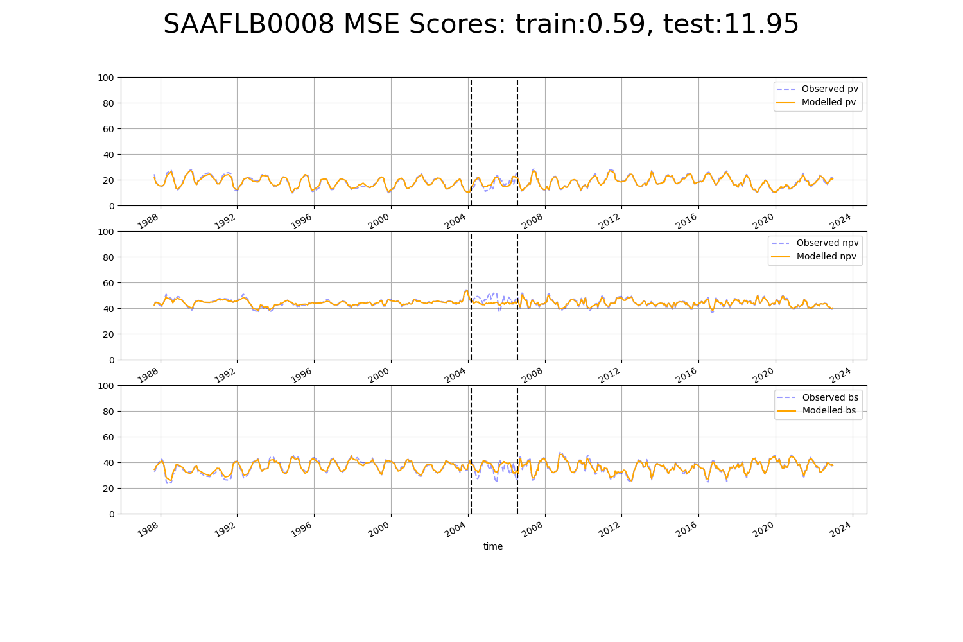

# SAAGAW0001

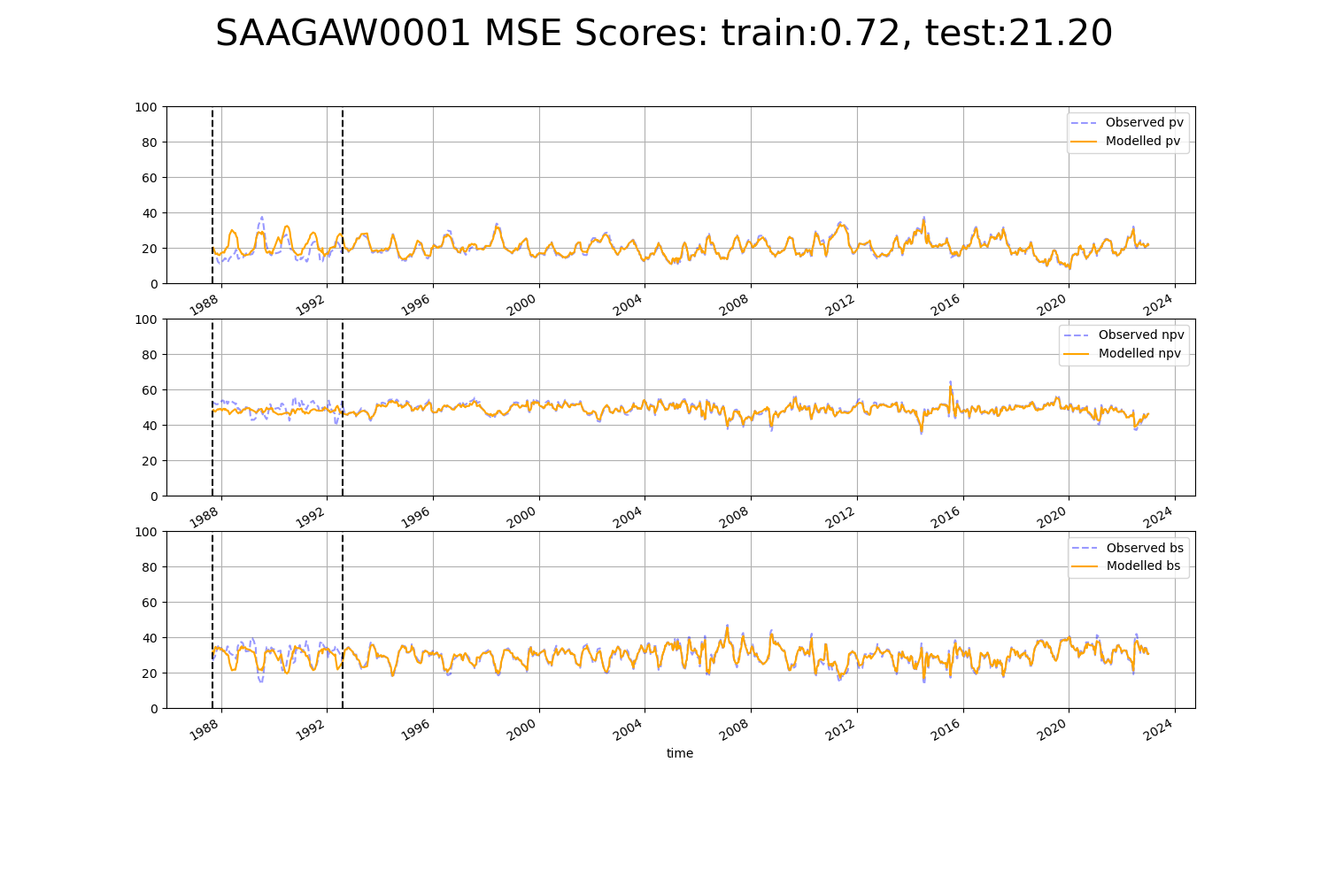

# SAAGAW0004

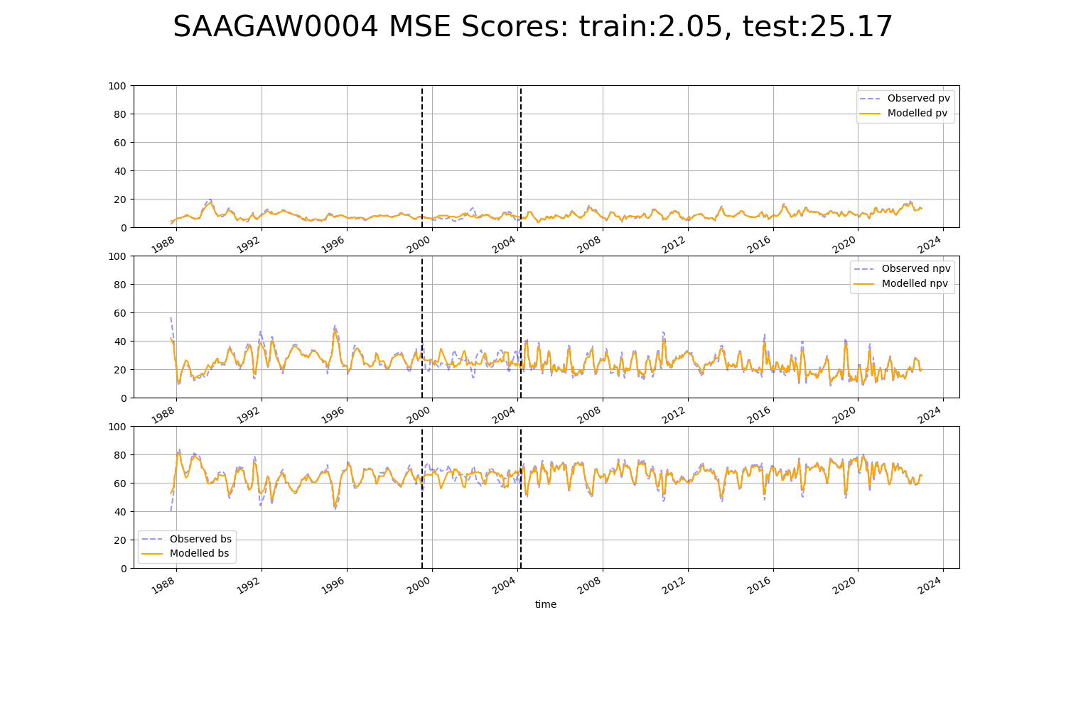

# SAARIV0001

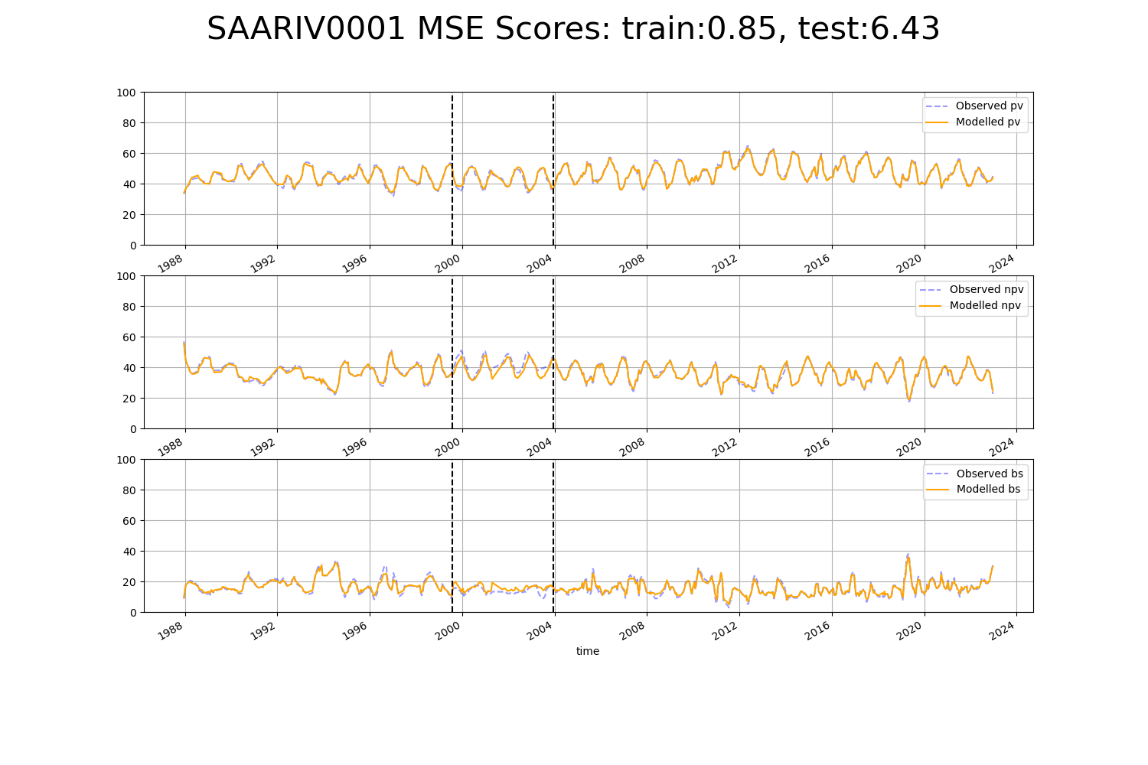

# SAARIV0002

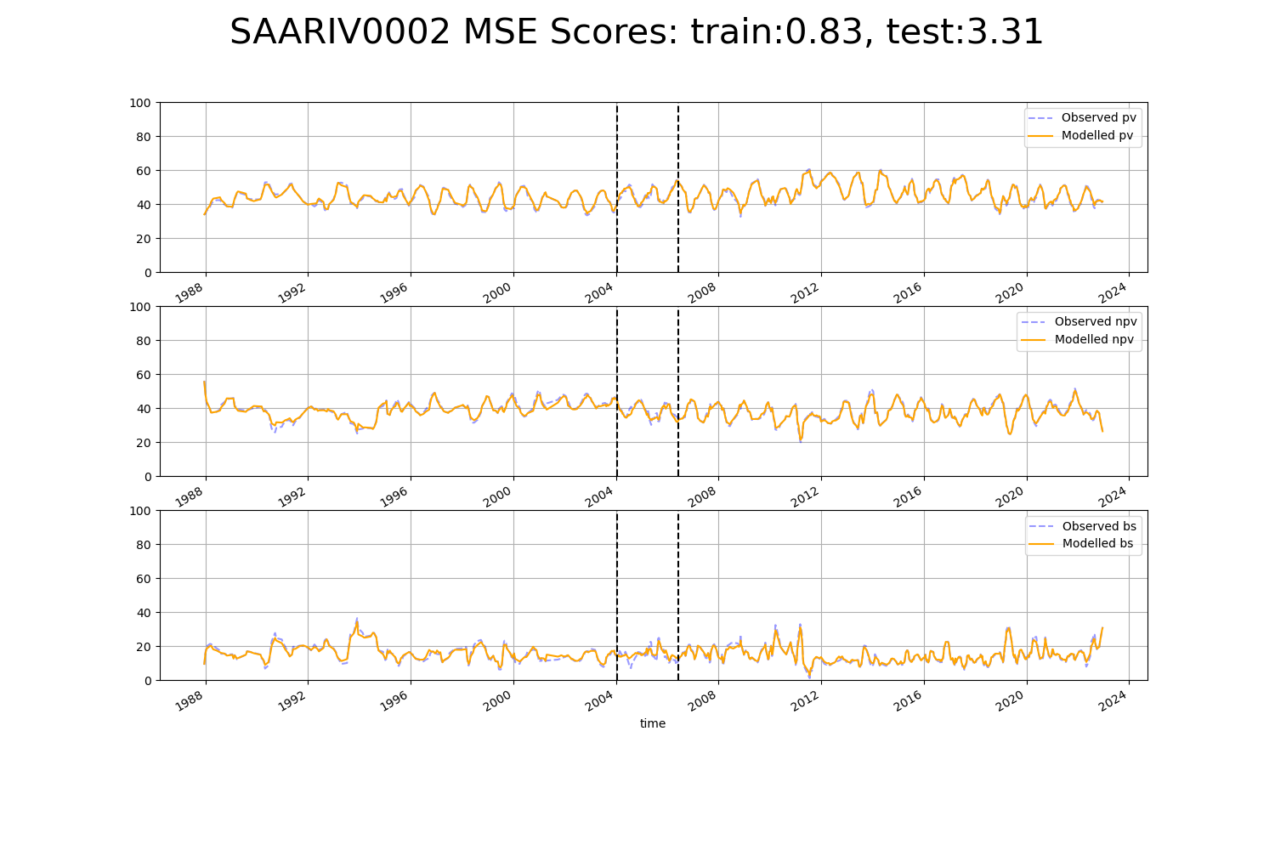

# SAARIV0003

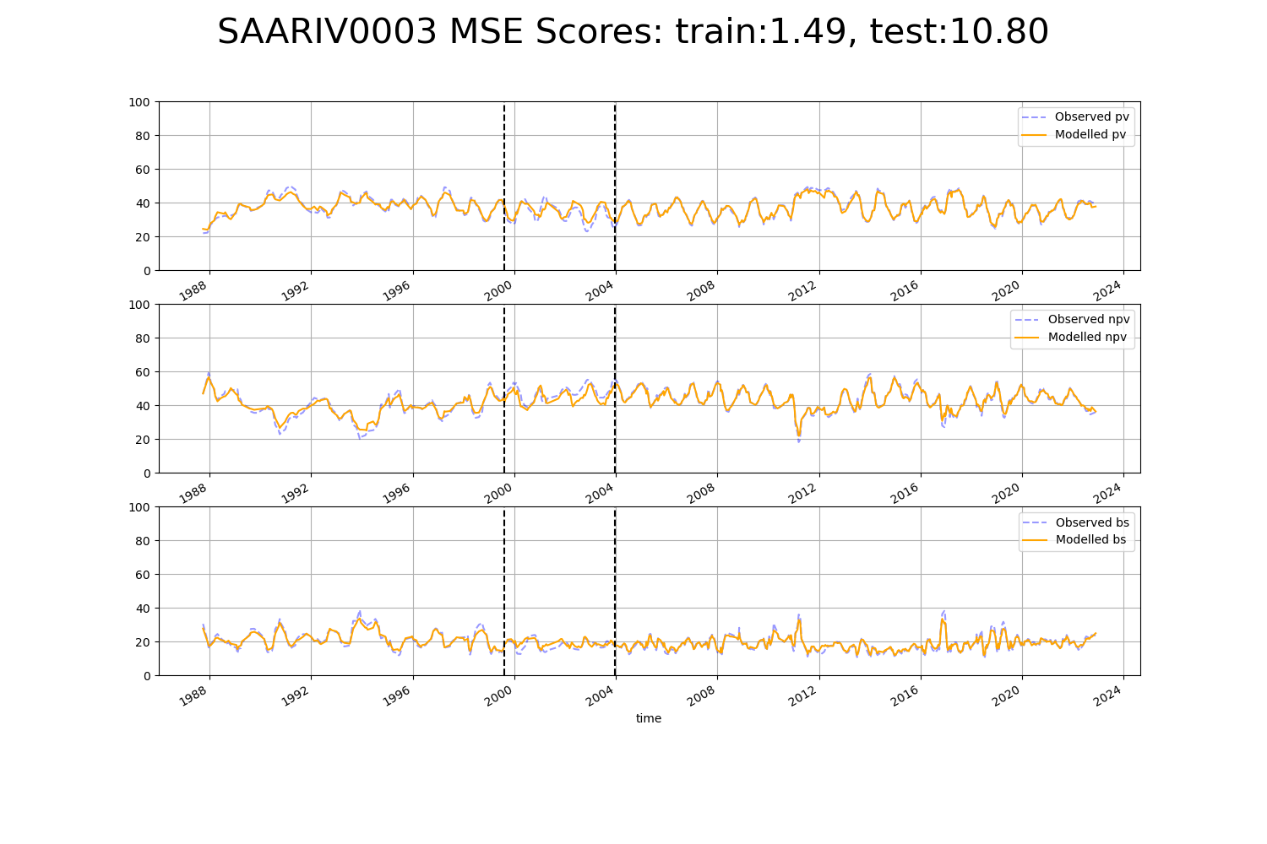

# SASMDD0001

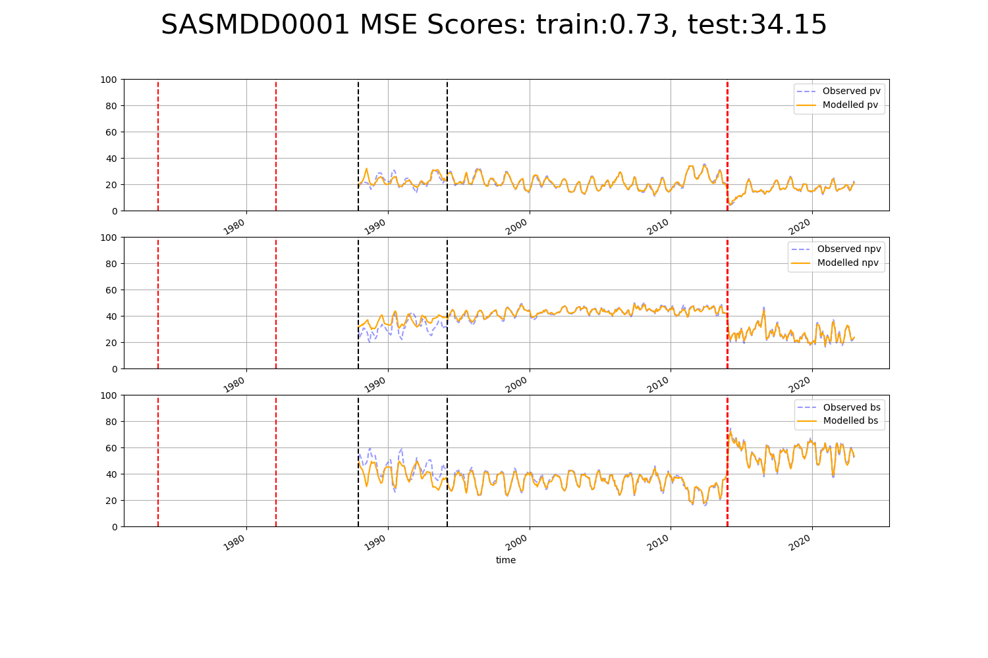

# SASMDD0002

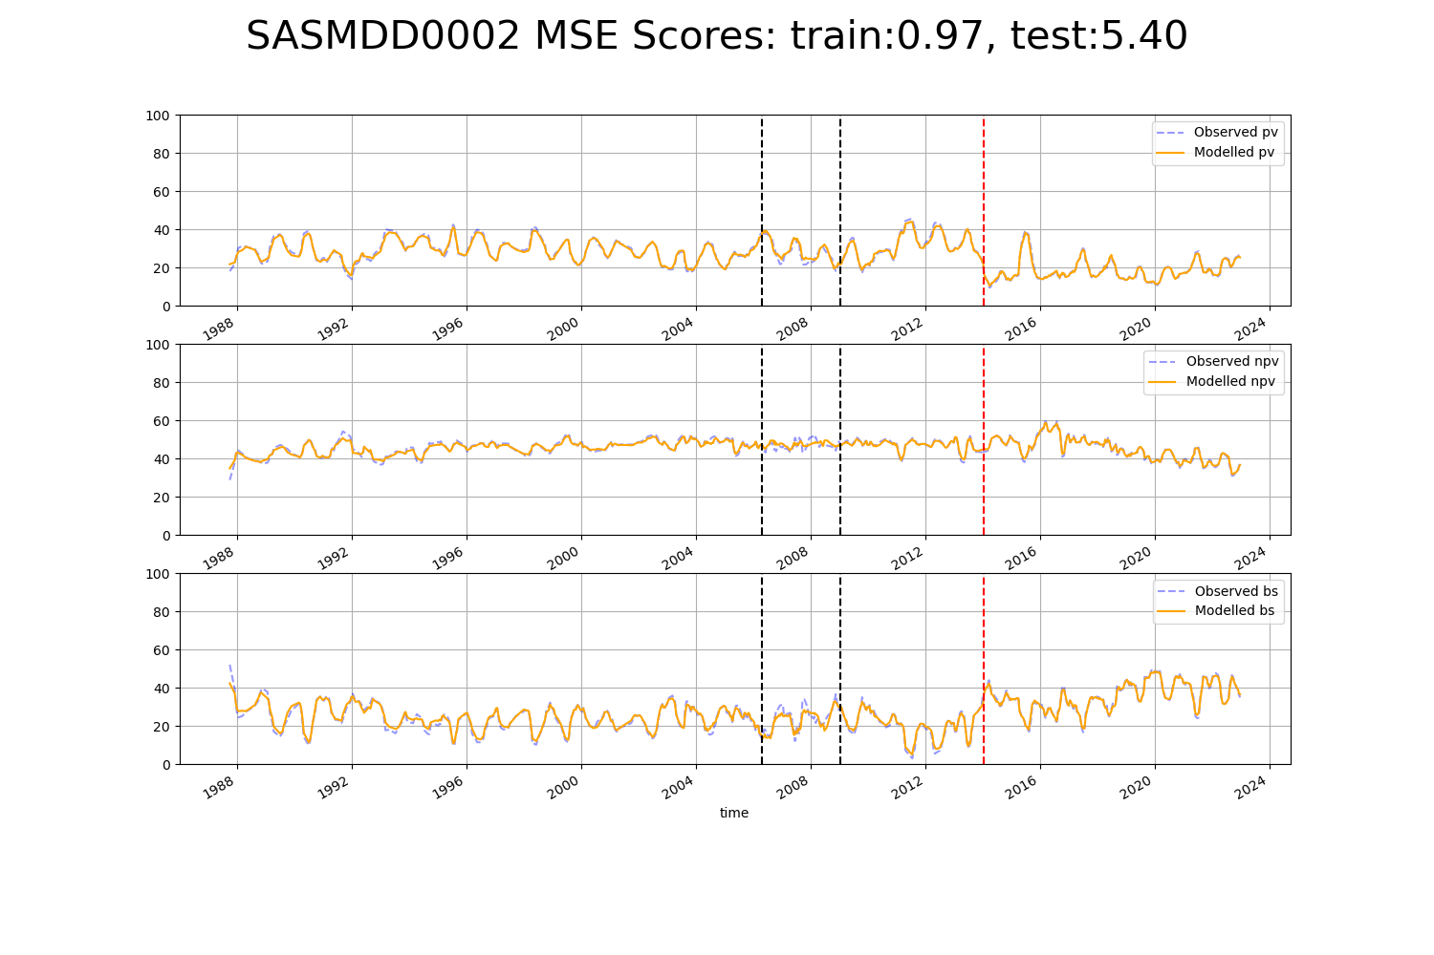

# SASMDD0006

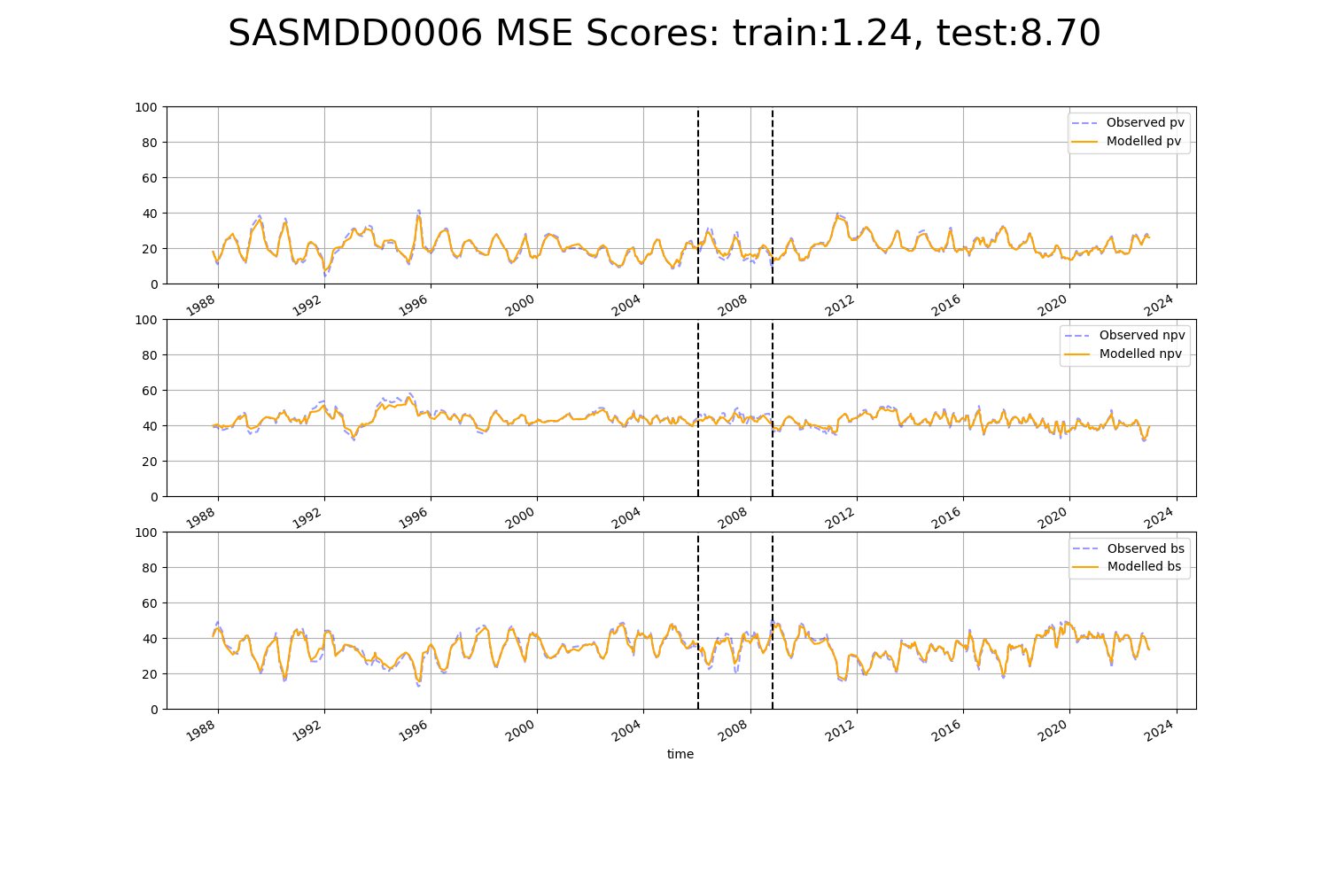

# SASMDD0008

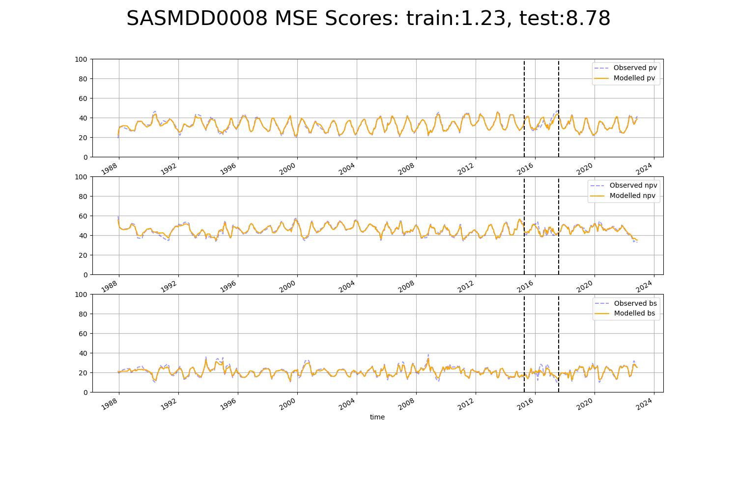

# SASMDD0012

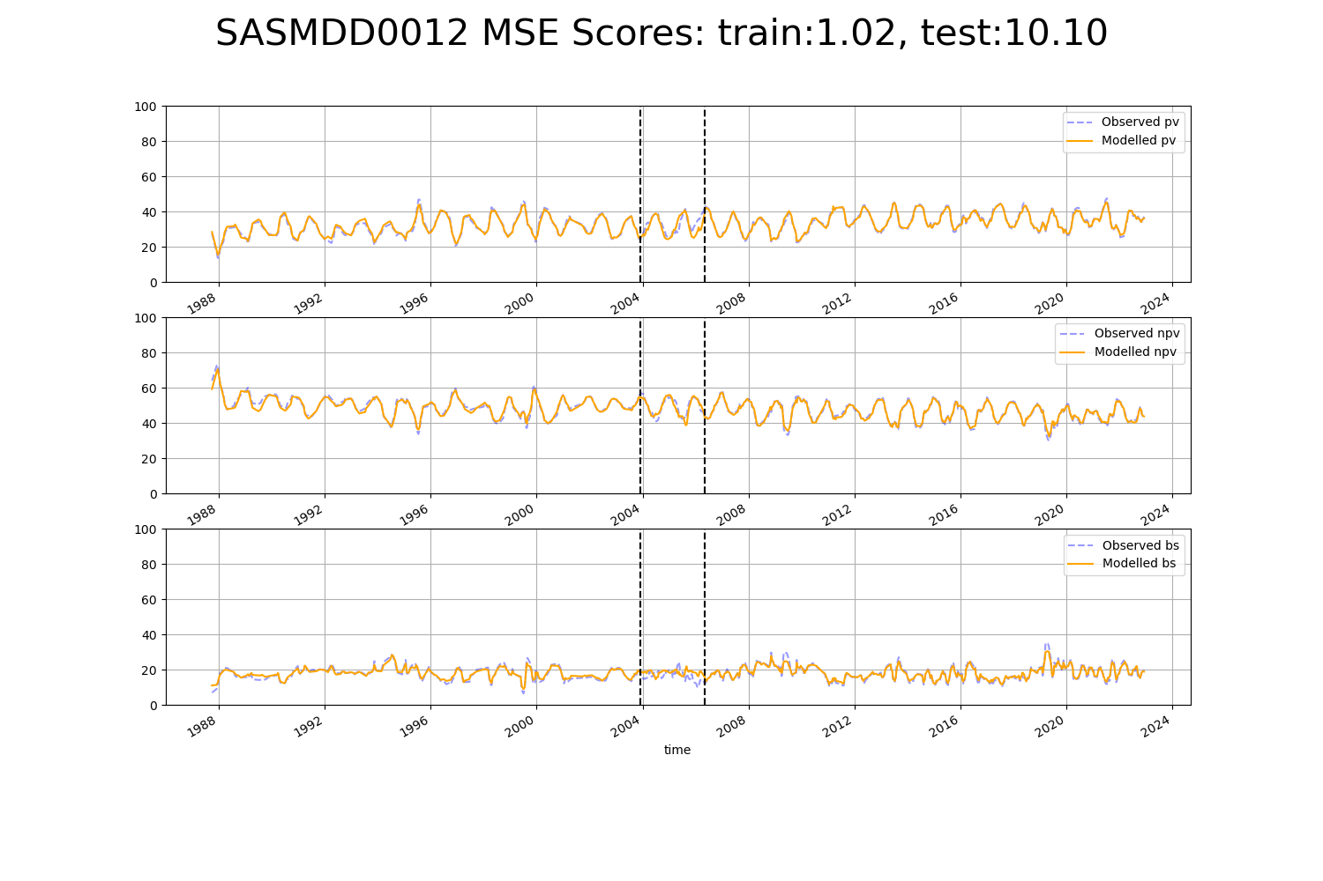

# SASMDD0016

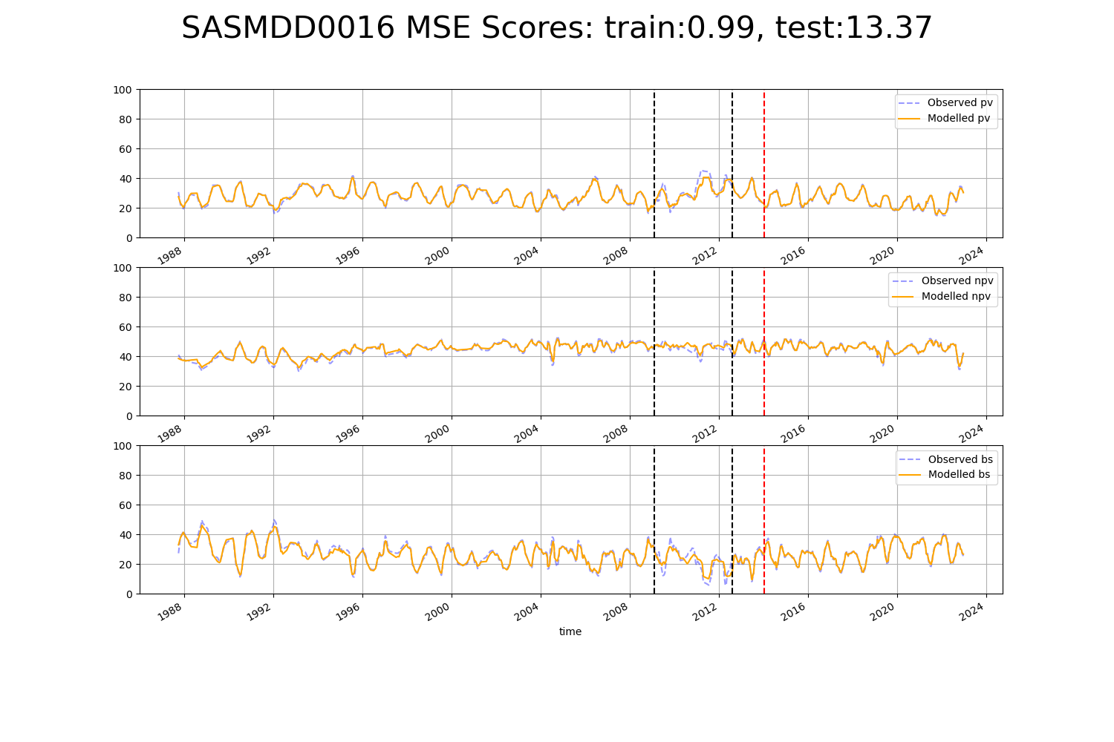

# SASMDD0017

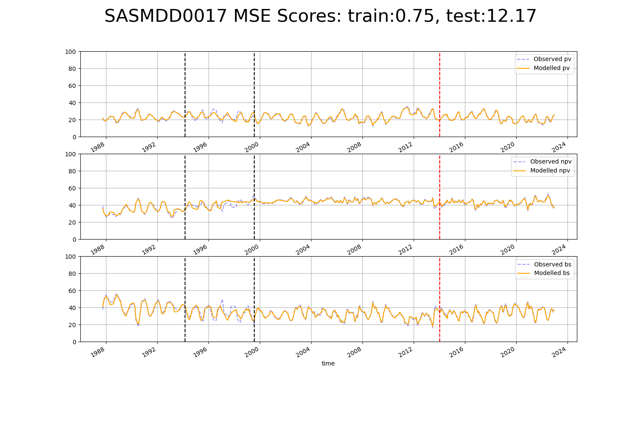

# SASMDD0018

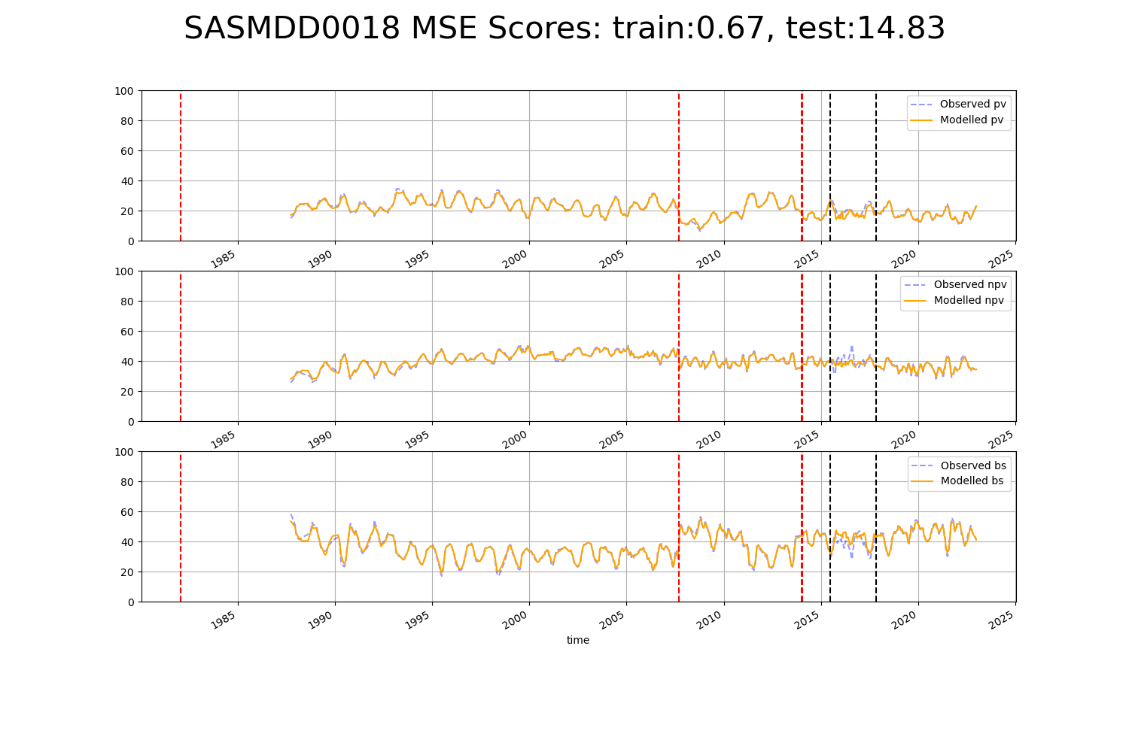

# SATFLB0004

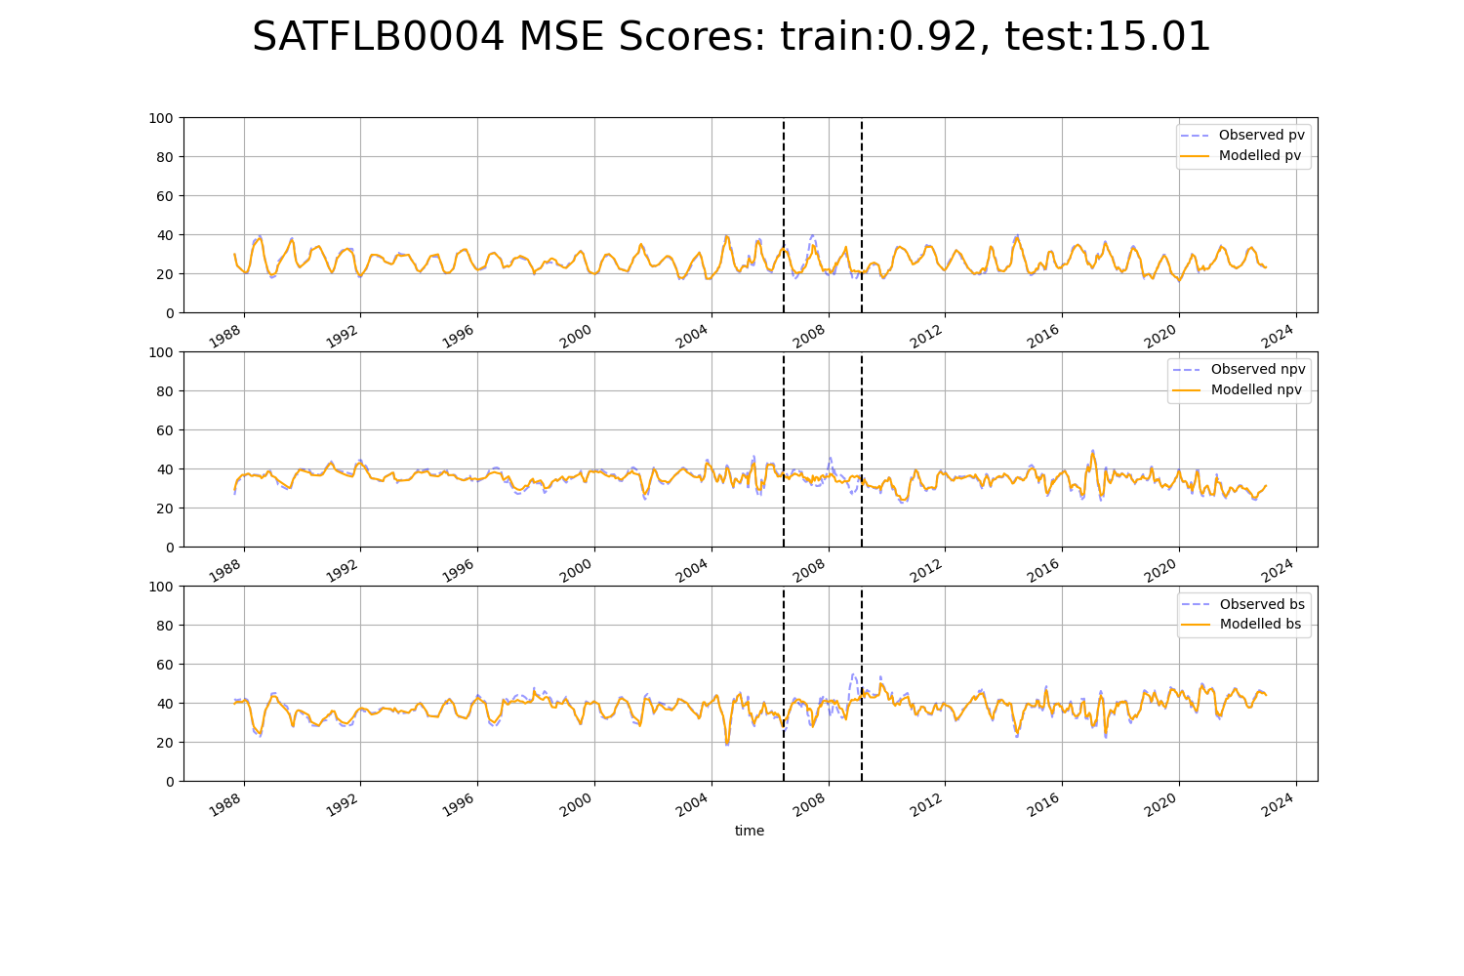

# SATFLB0010

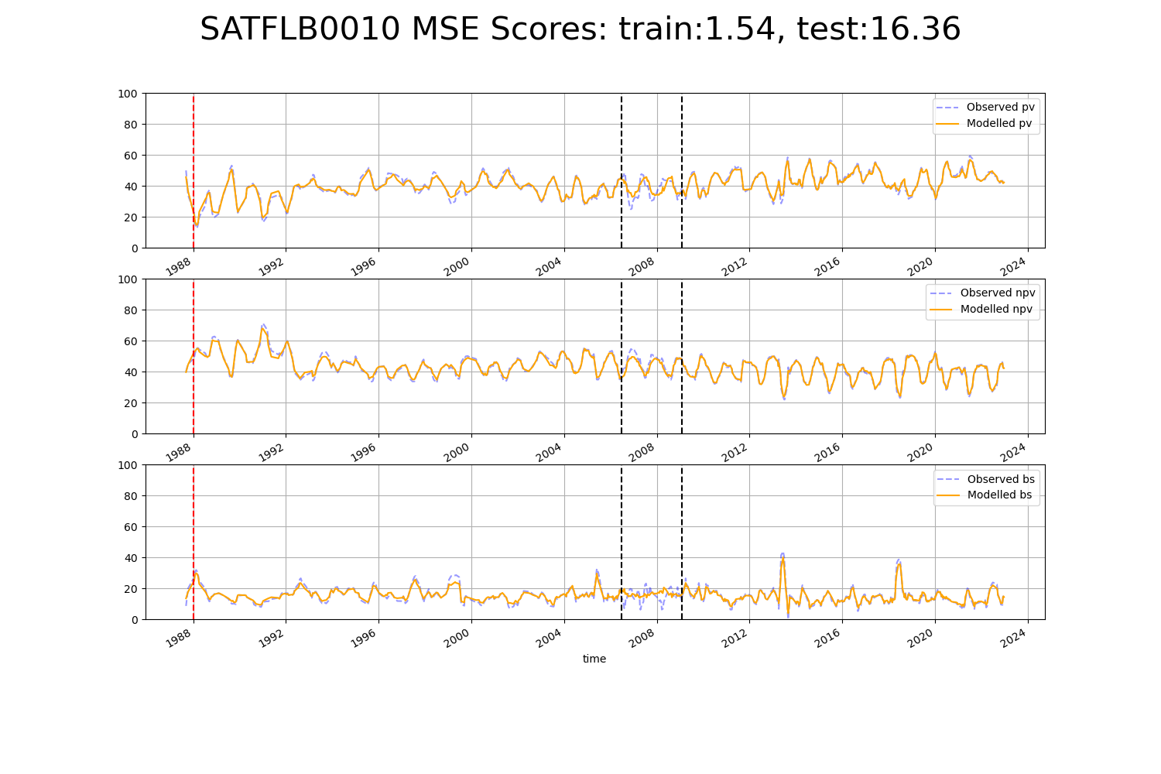

# SATFLB0011

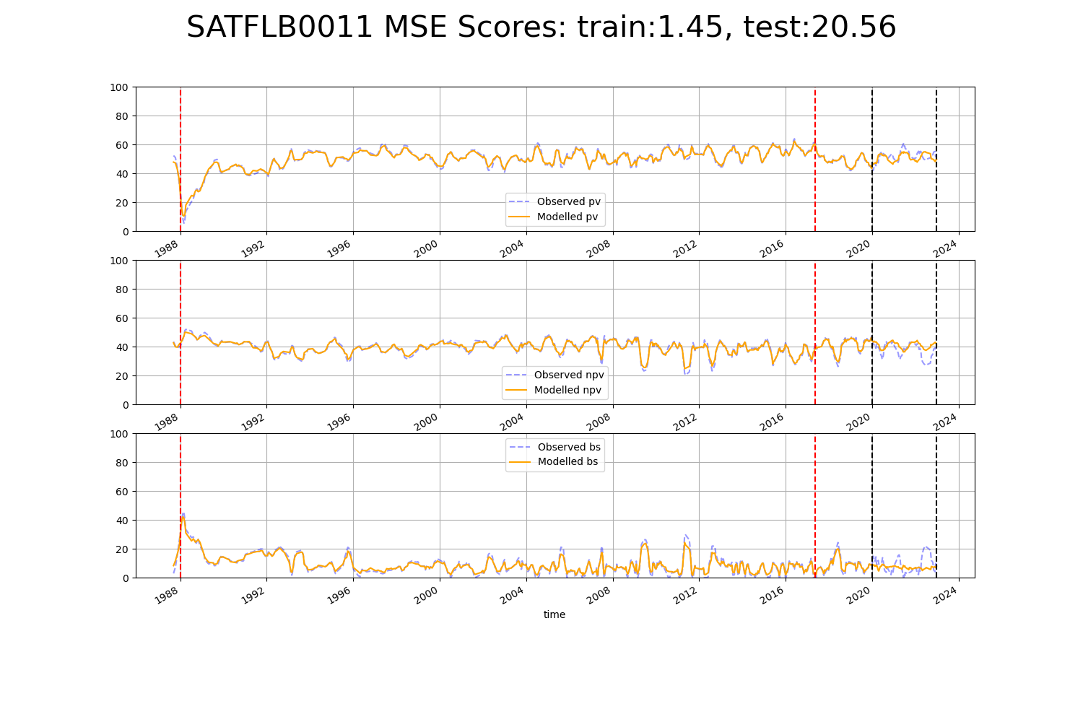

# SATFLB0016

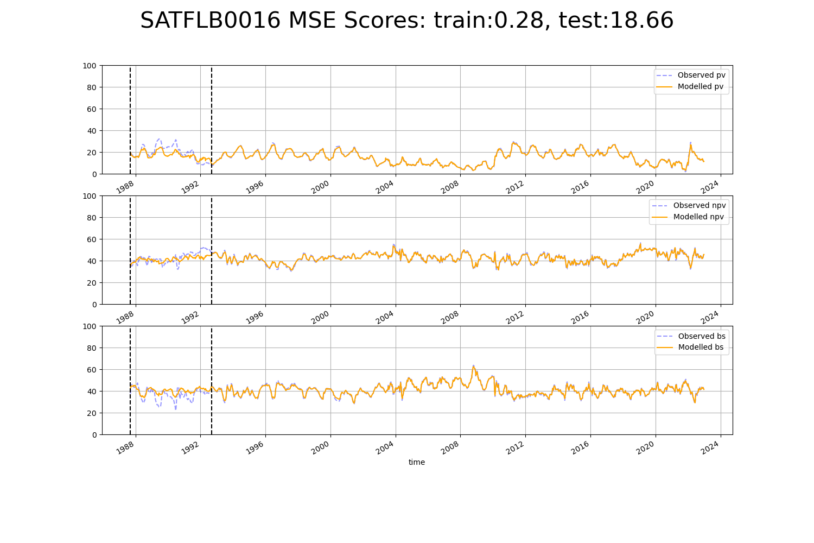

# SATFLB0020

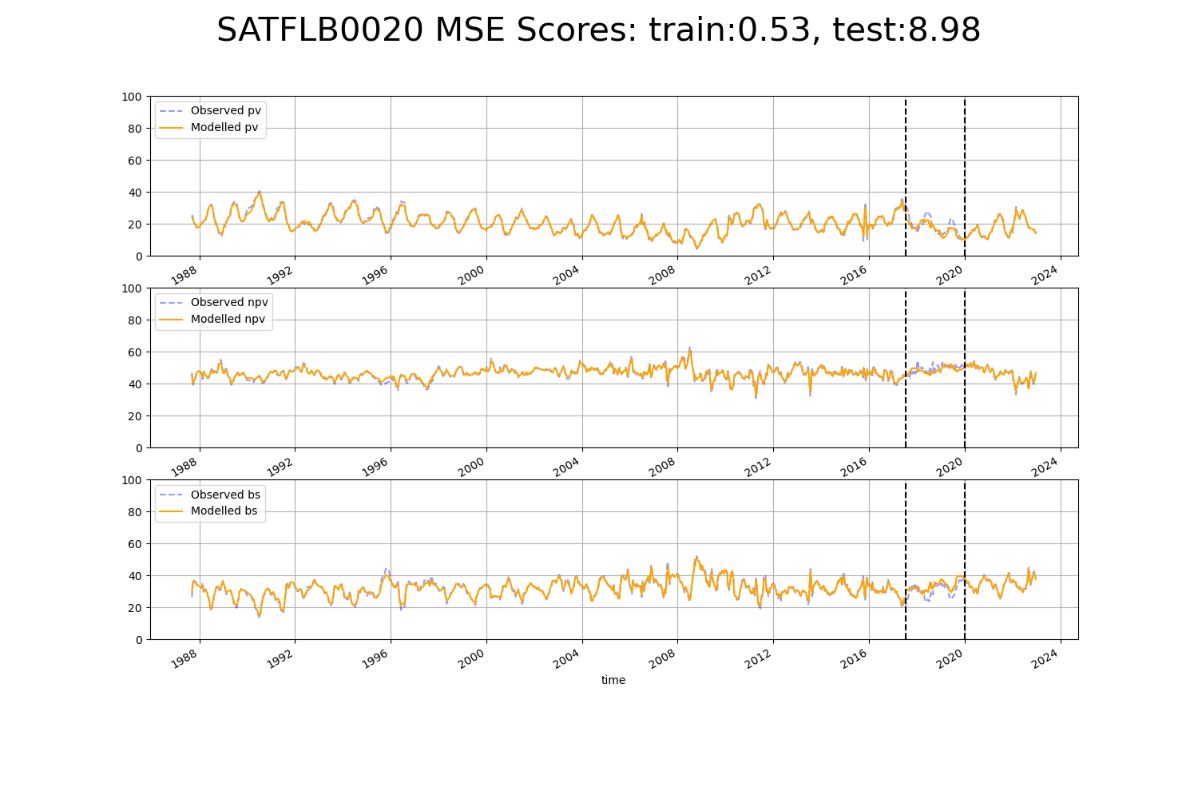

# SATFLB0022

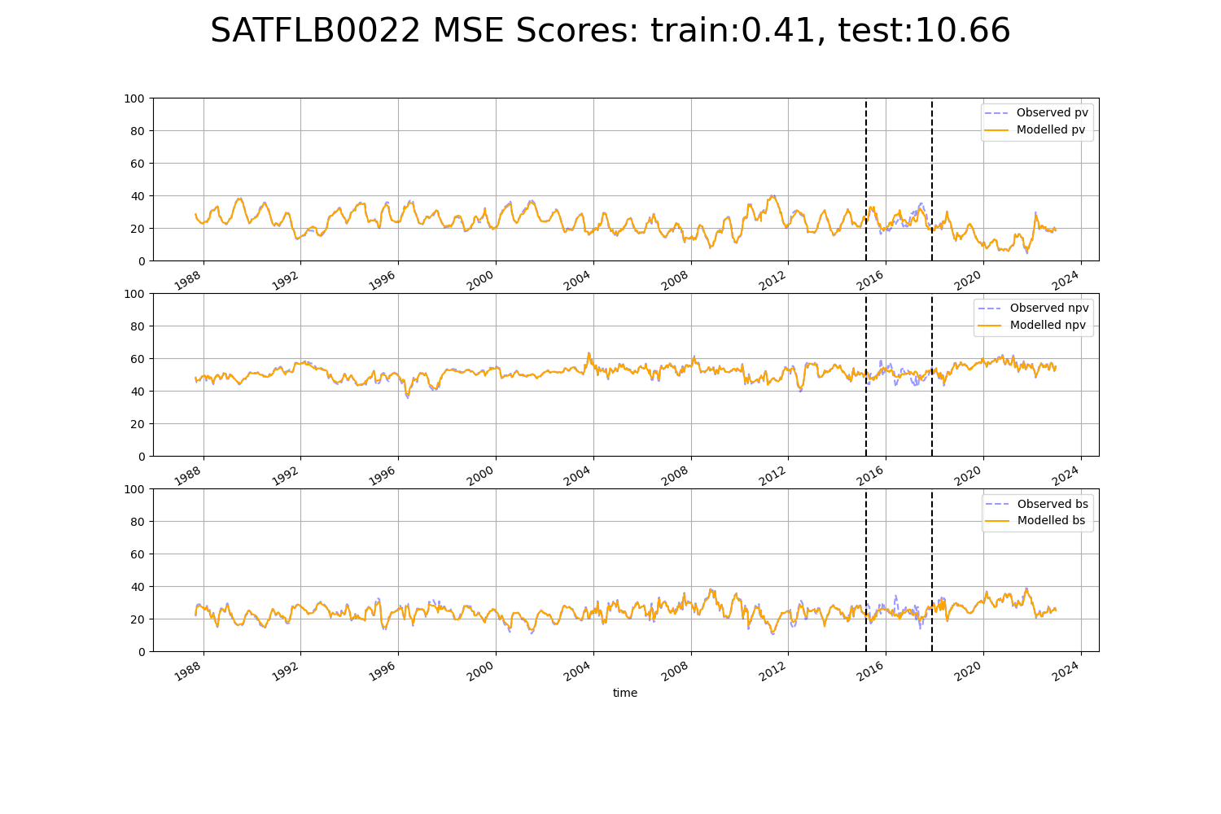

# SATFLB0025

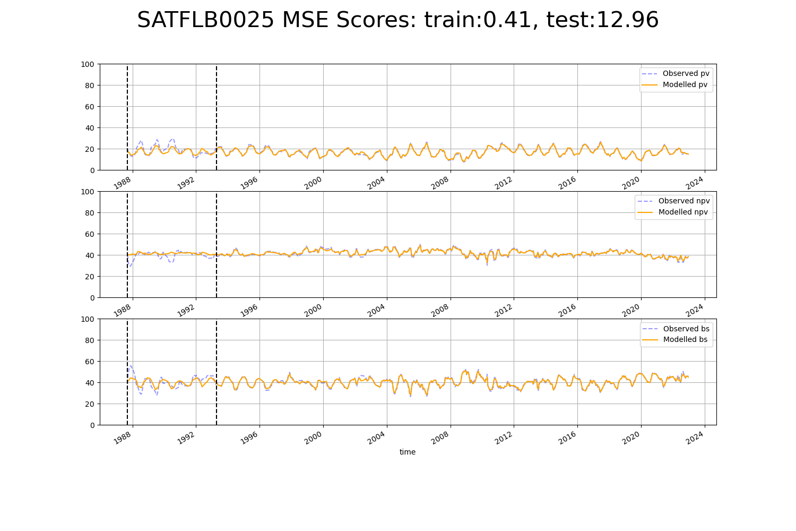

# WAACAR0002

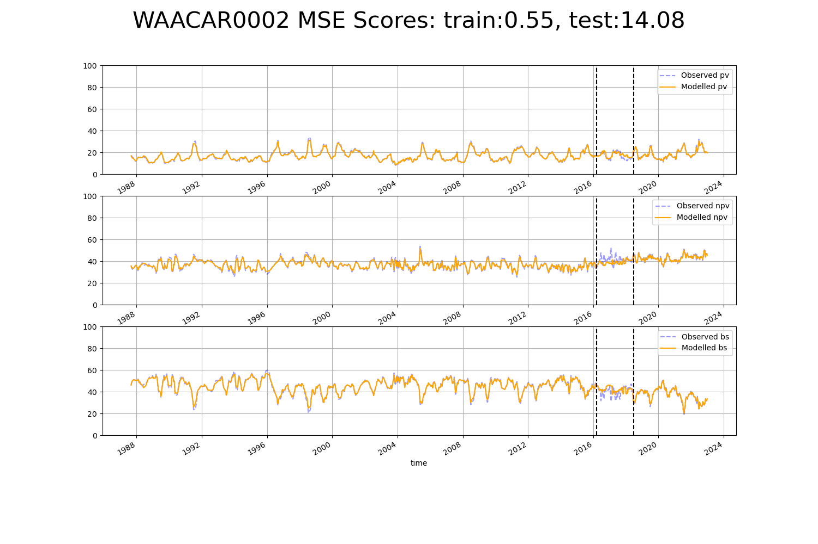

# WAACOO0012

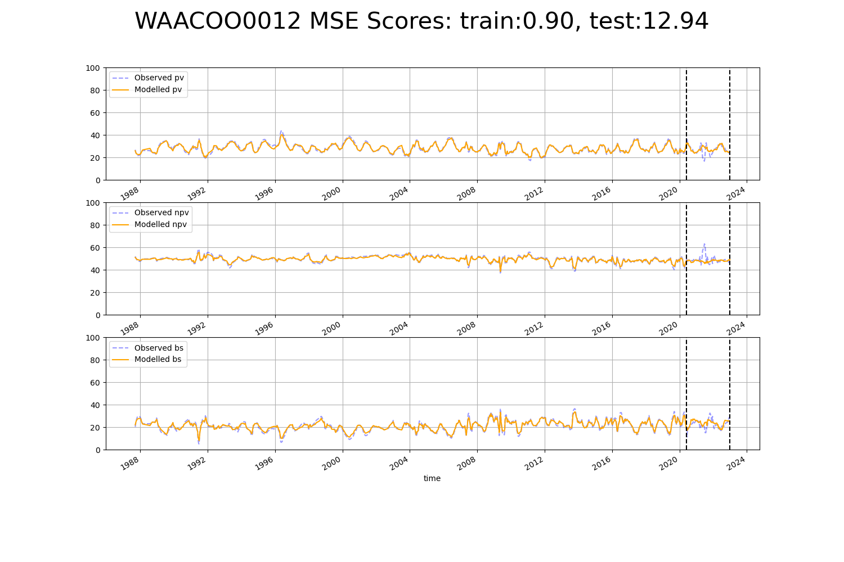

# WAACOO0022

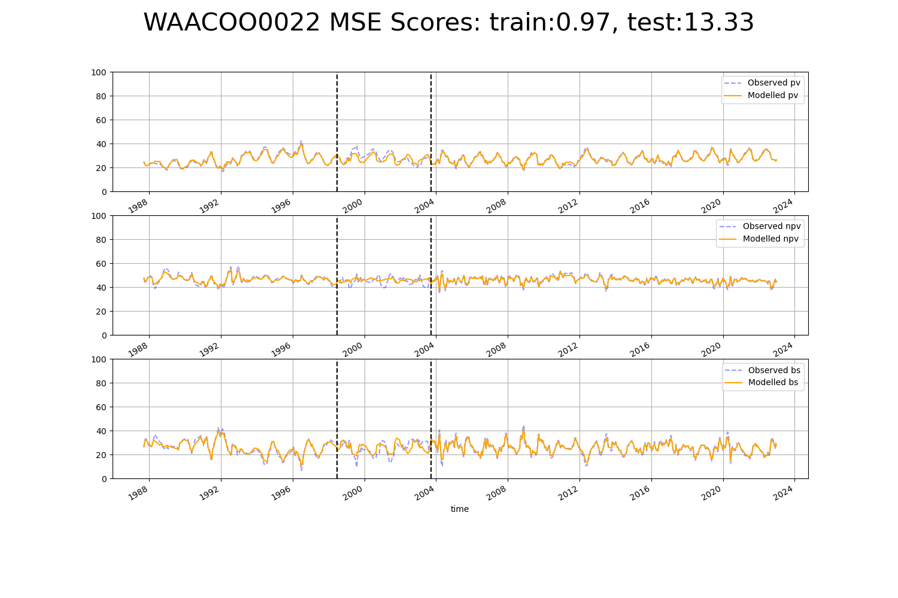

# WAACOO0023

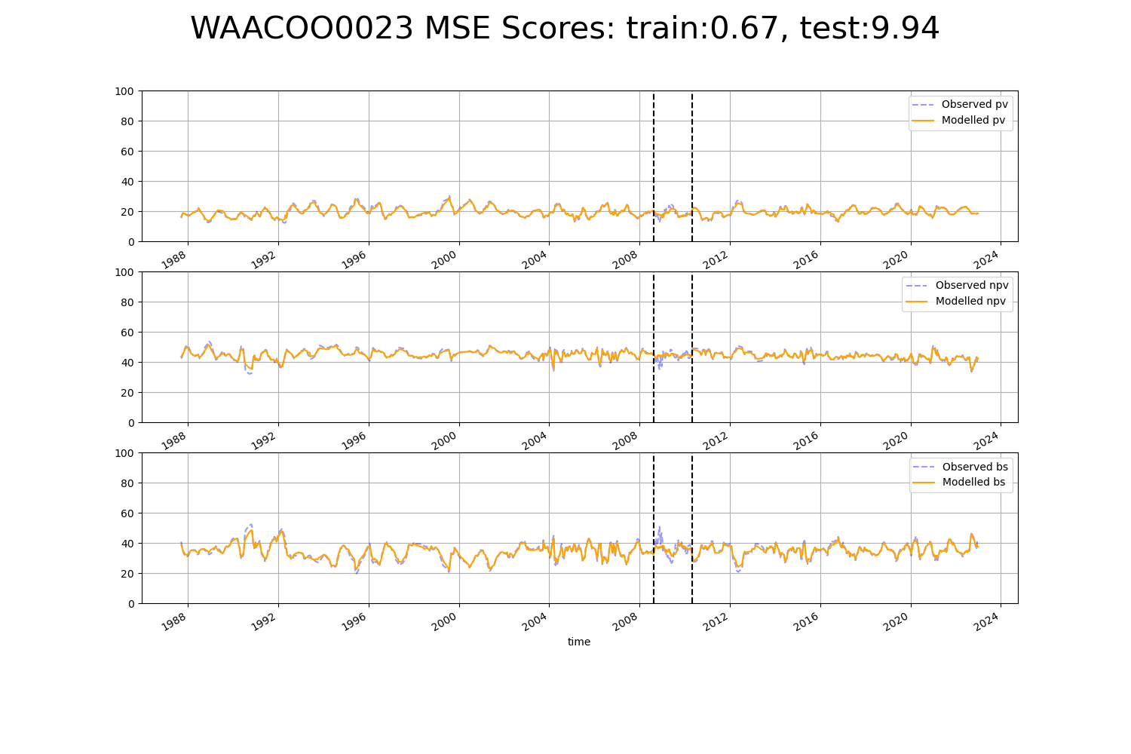

# WAAGAS0001

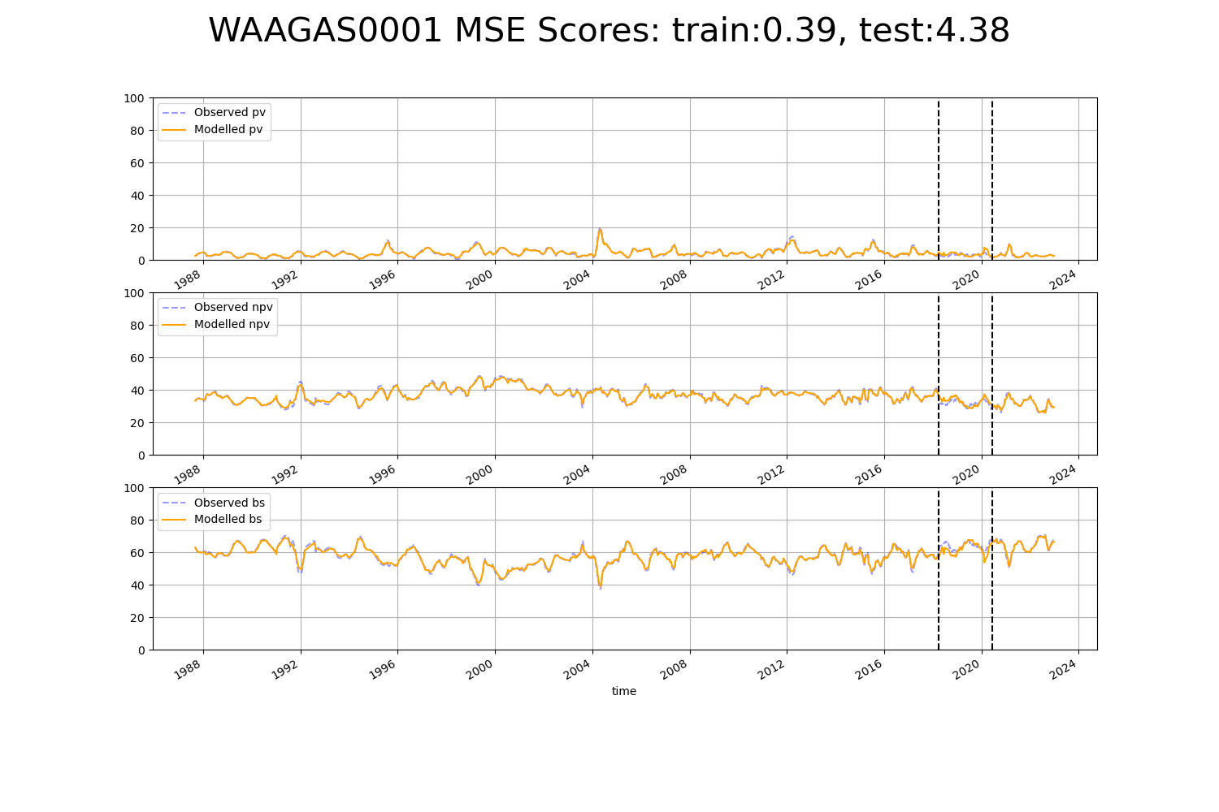

# WAAHAM0006

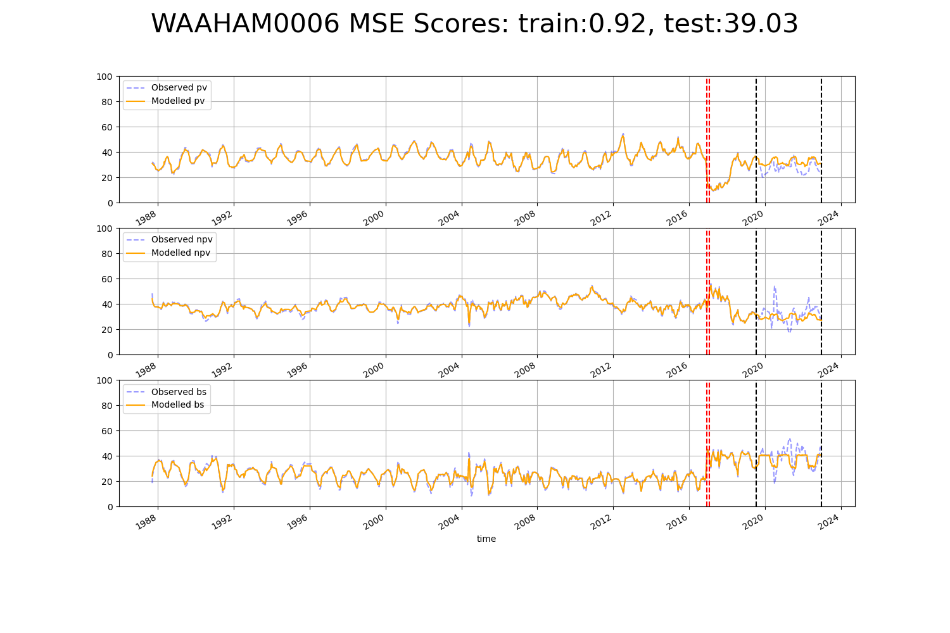

# WAAPIL0014

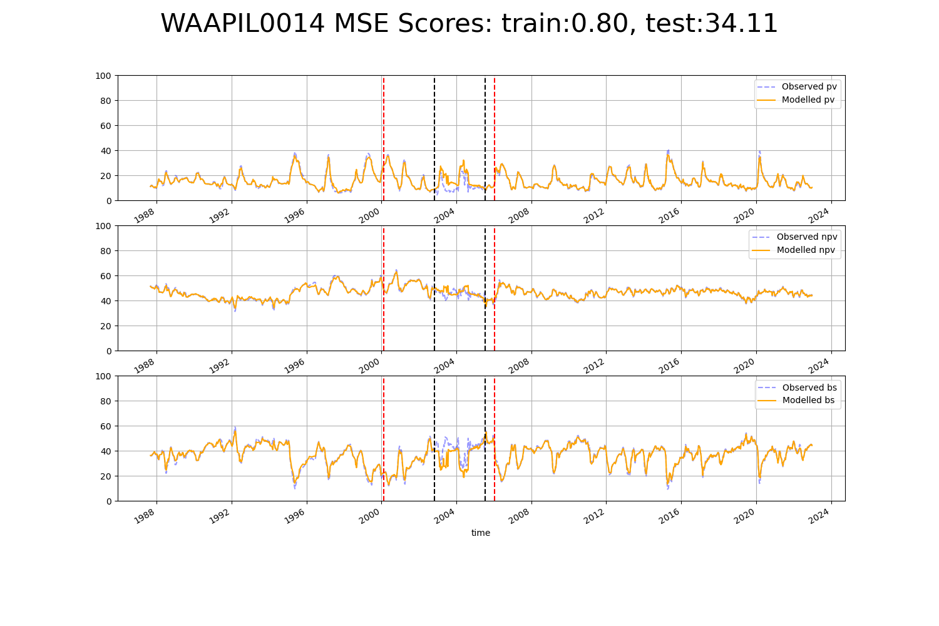

# WAAPIL0016

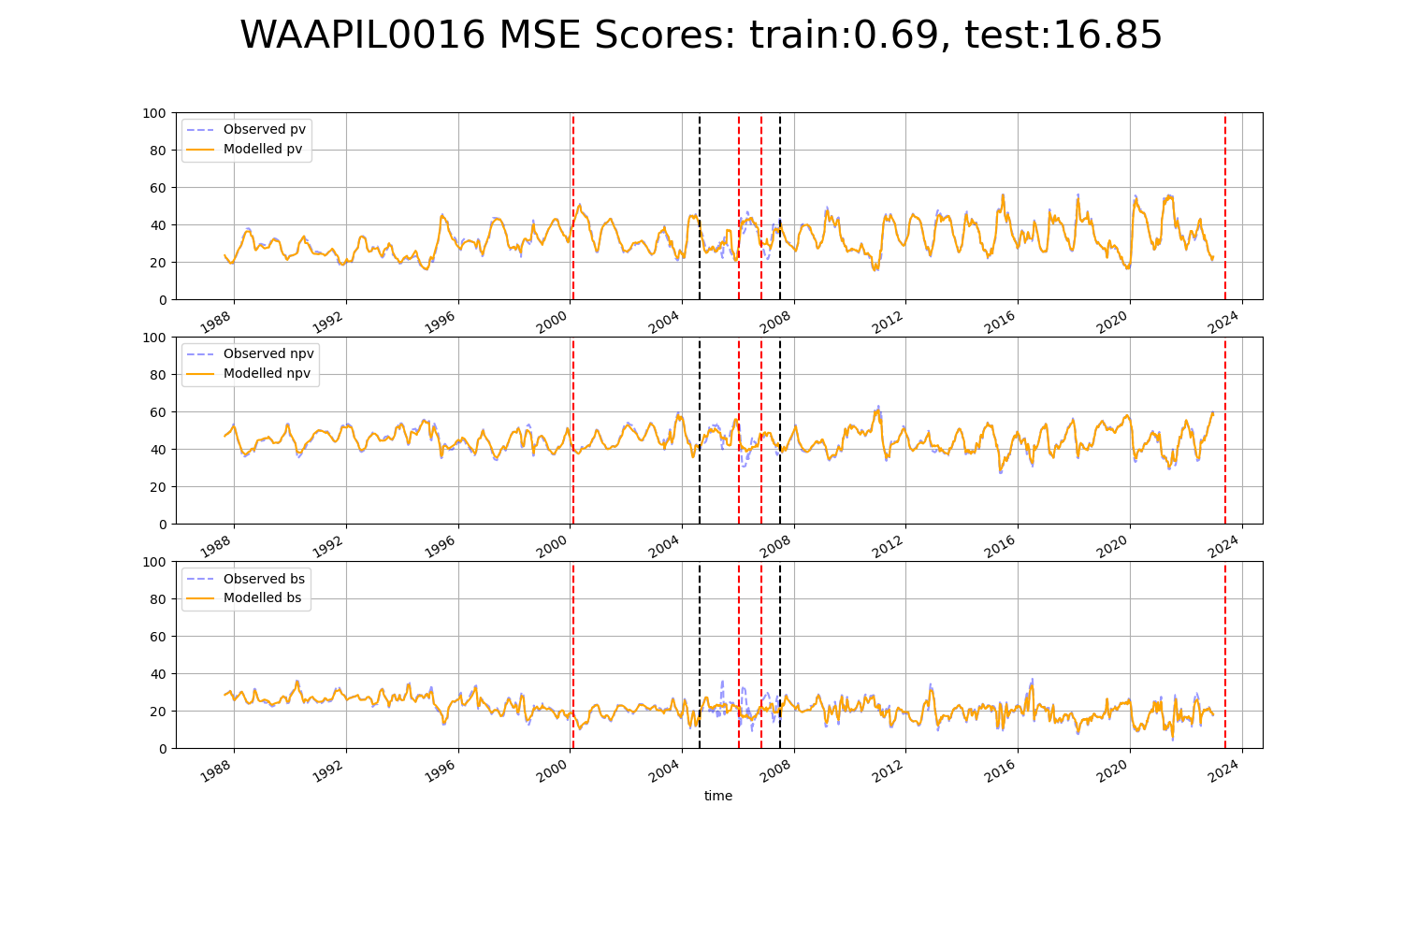

# WAAPIL0022

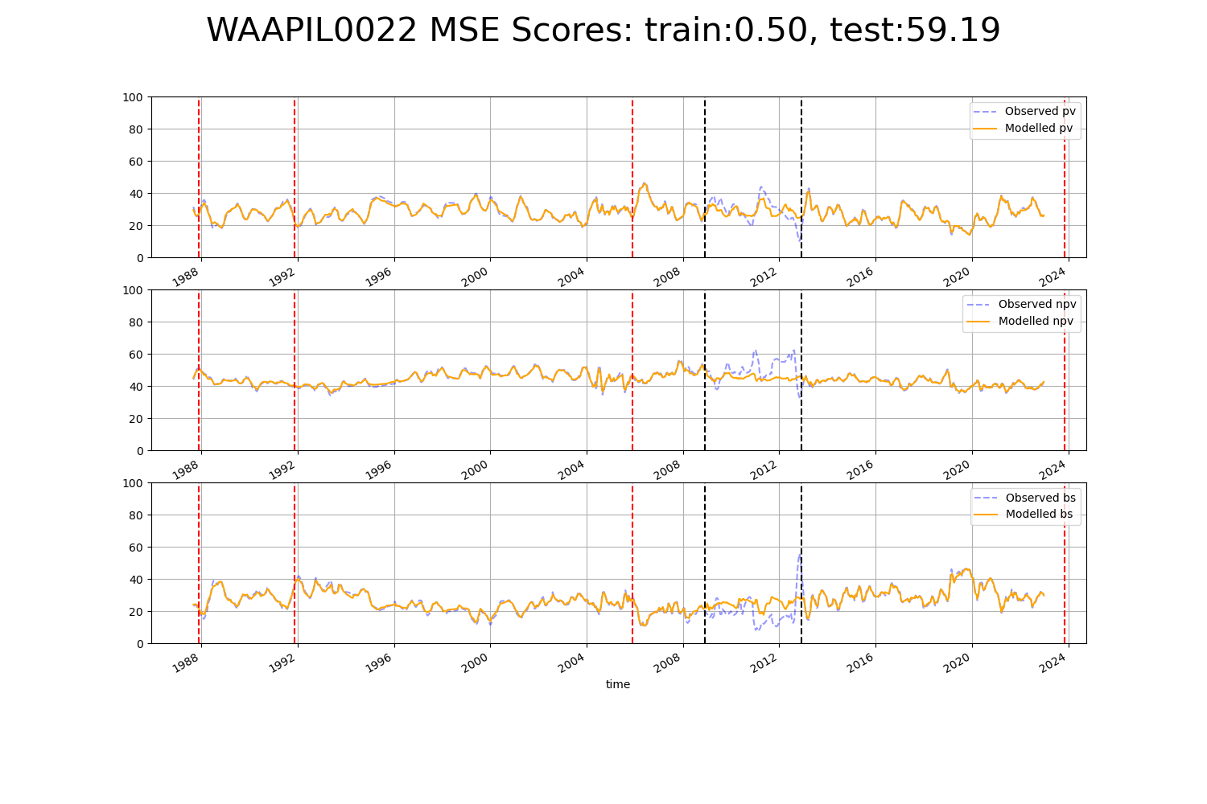

# WAAPIL0023

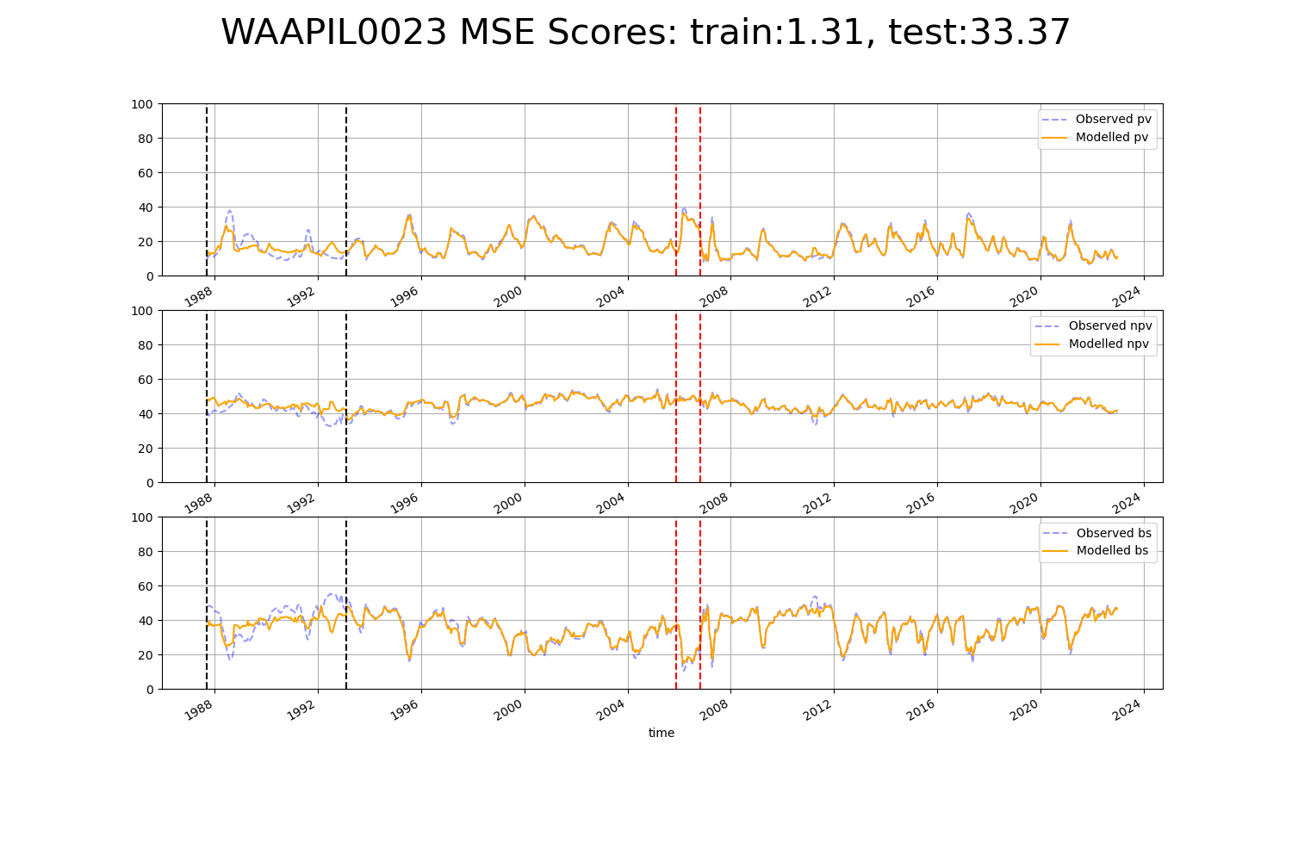

# WAAPIL0025

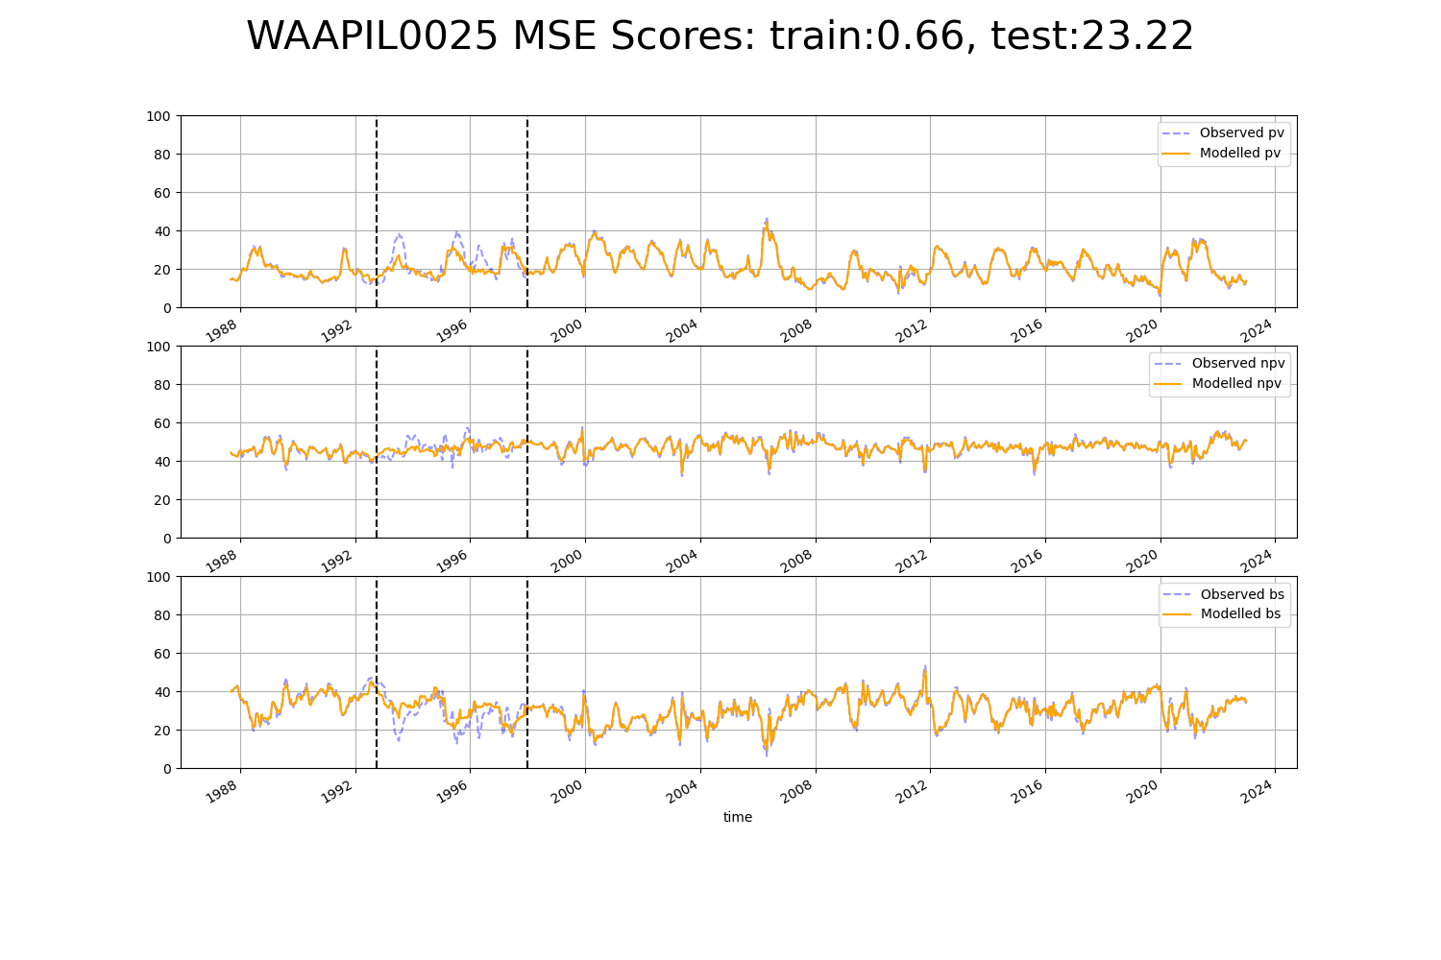

# WAAPIL0029

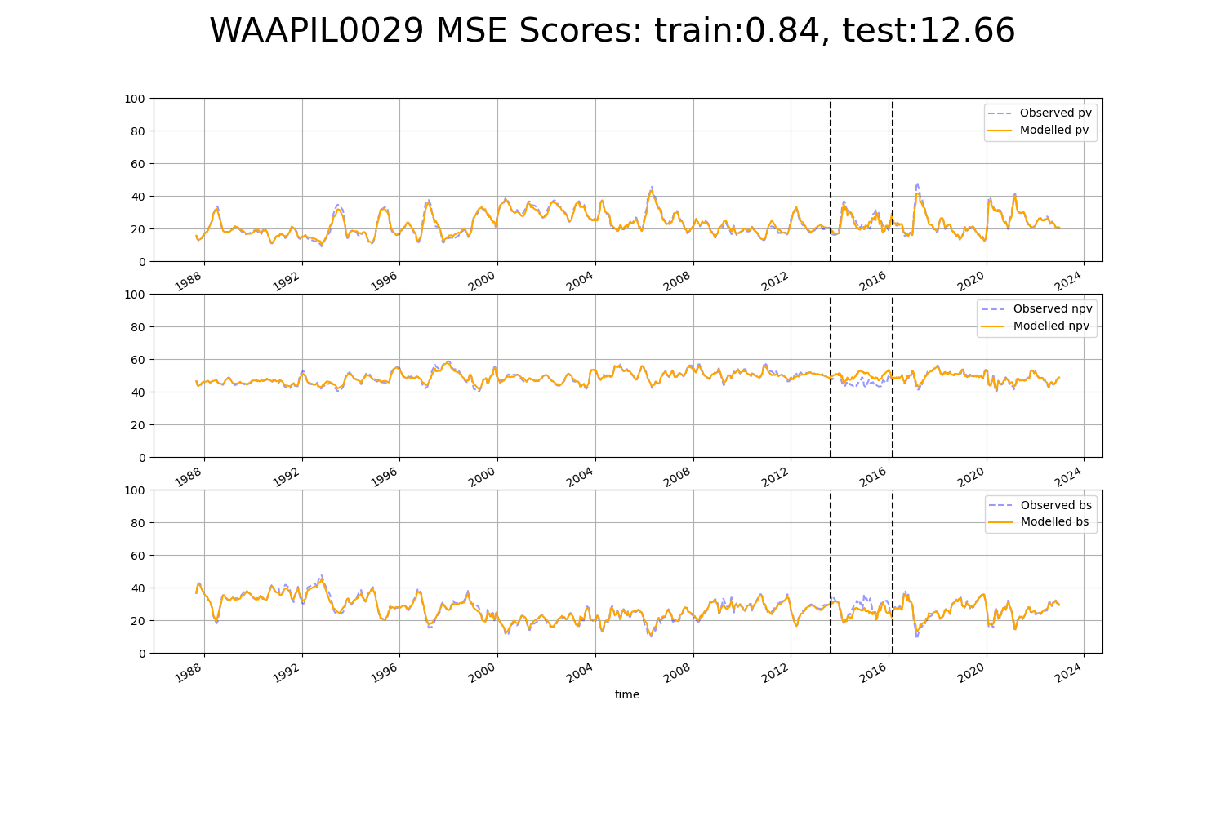

# WAGCOO0001

